

***“i2b2/tranSMART”***

***A statistical tool***

***to generate***

***research hypothesis***

SUMMARY

I. Quick overview 3

II. Introduction 5

V. Guide for using the statistical tool of i2b2/tranSMART 9

A. GENERATE SUMMARY STATISTICS 15

B. ADVANCED WORKFLOW 18

C. DATA EXPORT (Level 2 data access only) 22

VI. Examples of statistical analysis for each registry 23

A. INTRACRANIAL HYPERTENSION REGISTRY (IHR) 23

a) Generate summary statistics 23

b) Advanced workflow 28

B. INTERNATIONAL PACHYONYCHIA CONGENITA RESEARCH REGISTRY (IPCRR) 30

a) Generate summary statistics 30

b) Advanced workflow 33

C. NORTH AMERICAN MALIGNANT HYPERTHERMIA REGISTRY (NAMHR) 35

a) Generate summary statistics 35

b) Advanced workflow 38

D. WOLFRAM SYNDROME INTERNATIONAL REGISTRY (WFS) 40

a) Generate summary statistics 40

b) Advanced workflow 42

VII. GRDR Common Data Elements 45

A. DEFINITION 45

B. STATISTICAL ANALYSIS USING GRDR CDEs 46

VIII. Annexes 47

IX. Bibliography 48

# **I. Quick overview**

INTRACRANIAL HYPERTENSION REGISTRY

-**Is there an association between “papilledema” *and* “high level of intracranial pressure”?**

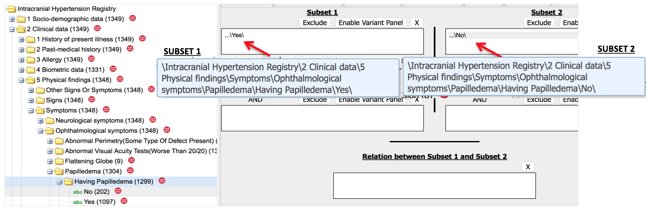

Click on Generate Summary Statistics

Then “drag” and “drop” the variable *“TAP1 pressure”*

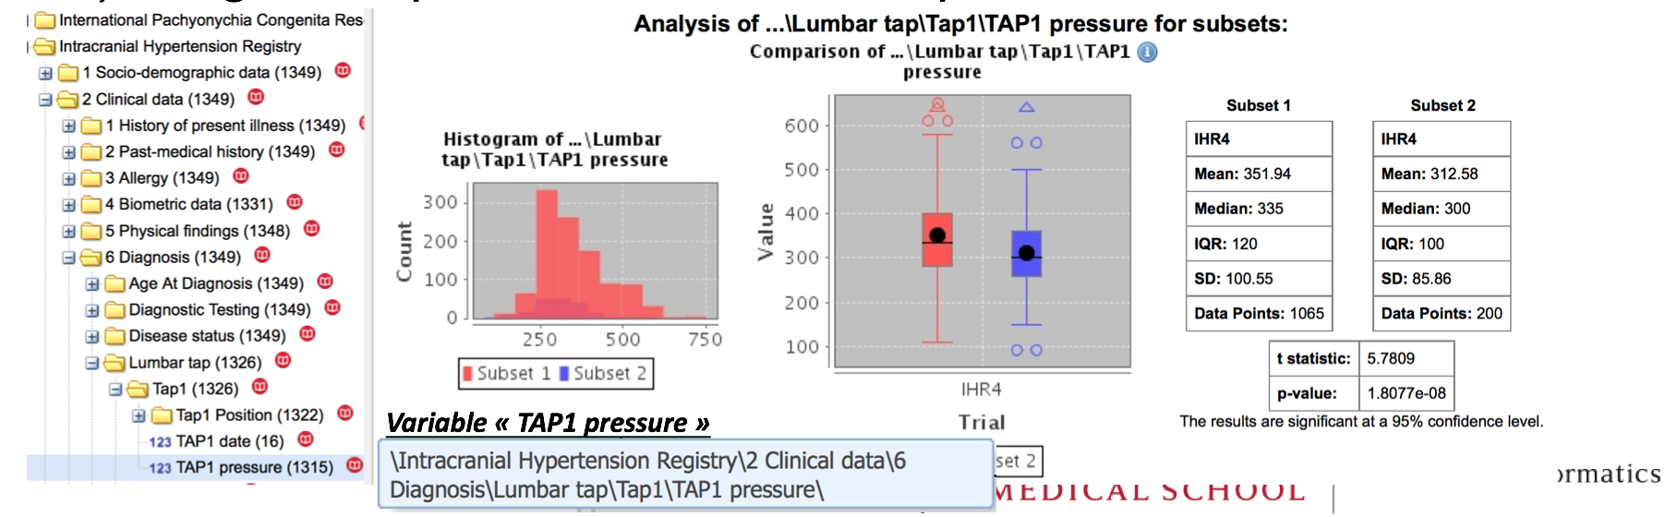

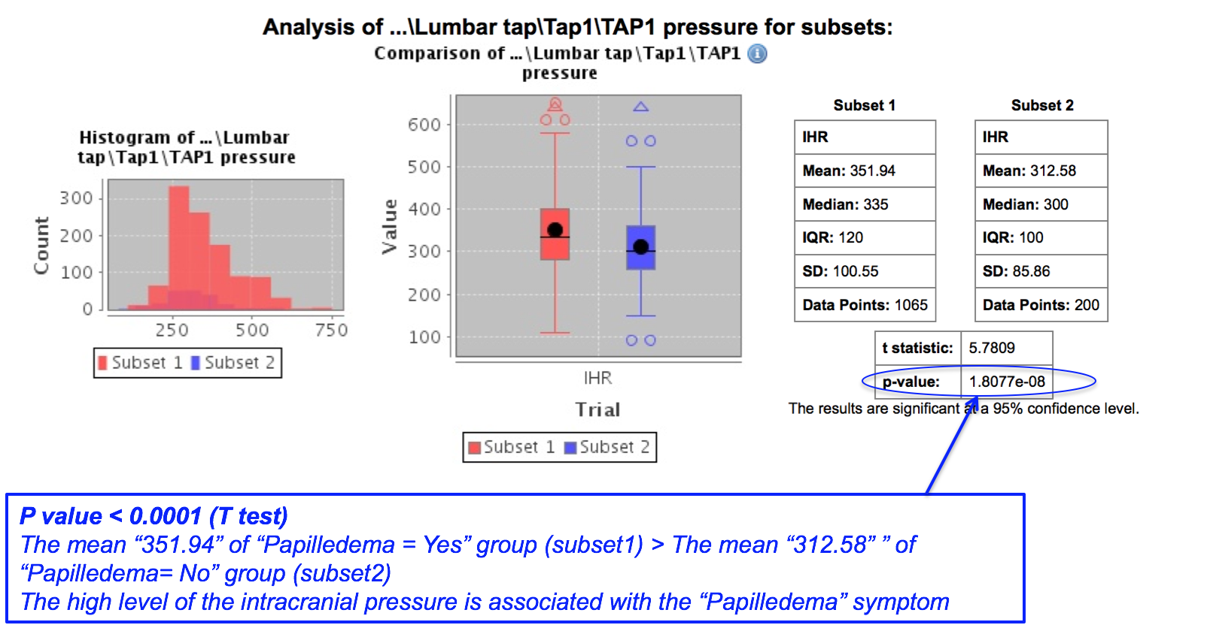

# **II. Introduction**

**I2b2/tranSMART**

I2b2 (or Informatics for Integrating Biology and the Bedside) is a scalable informatics framework designed primarily for translational research. tranSMART is an application layer to i2b2.

It allows all of the functionality of i2b2, plus the ability to perform complex statistical analysis, load data using a simple Excel spreadsheet, and the ability to integrate ‘omics and additional phenotype data from multiple sources.

The primary objectives of i2b2/tranSMART are the integration of clinical, biological, and ‘omics data (including such data as genomic test results) in one place, and the generation of hypotheses by investigators interested in using the data for their research.

**The NIH/NCATS GRDR® Program**

The aim of the GRDR program is to develop a Web-based resource that aggregates, secures and stores de-identified patient information from many different registries for rare diseases, all in one place.

The ultimate goal of the GRDR program is to provide a “one-stop shop” for rare disease data from registries across the world. Through the program, NCATS will give patients, health care professionals and researchers access to information about multiple rare diseases through one central resource.

Studies driven by GRDR data could lead to improved therapeutic development and quality of life for the many millions of people who have rare diseases

**III. Authentication/authorization**

**Authentication**

The i2b2/tranSMART system has been modified to use [Auth0](http://auth0.com/) as an Identity Manager for authentication. It allows the platform to use the participant's own Identity Providers to authenticate a user (usually with their own e-mail address) and establish a three-way trust relationship between the Identity Manager, the Identity Provider and the i2b2/tranSMART application.

When a user enters their e-mail address on the login screen, Auth0 recognizes a known e-mail domain, and redirects the user to enter their credentials on their own provider's webpage.

Using the standard SAML protocol, a validated user's credentials will be passed back to Auth0, which in turn will redirect the authenticated user's browser to the i2b2/tranSMART application with all the information that a provider allows to be exposed.

i2b2/tranSMART will store the username/email and some additional variables (first name, last name) and the type of provider in its database. There is no password provided to i2b2/tranSMART, because it is entered at the Identity Provider's site, and only the temporary authentication data is passed on to the platform.



Fig 1: “Log in “page

**Authorization**

Authorization refers to the granting and managing of access levels within the i2b2/tranSMART installation. The manager of the system grants various access levels to users, based on requirements specified prior to signing up.

At the time of first authentication within the system, a small sign-up form is presented, where additional

information is gathered and two notifications are sent out. One is a confirmation e-mail back to the user (the email address that was used to log-in is used in all communications) and another e-mail to the manager of the platform, alerting her that a new user is requesting access.

There is no access to the system until the manager updates the user record with the appropriate level of access. An e-mail will be sent to the user what that action has taken place.

Once the user receives the e-mail that they have access (Level 1 - Open Access to Aggregate Counts) they will be able to log in and presented with the list of registries attached to the particular i2b2/tranSMART installation.

Initially, all users that the manager approves, will be granted Level1 access. This will allow the view of certain studies and the running of Summary Statistics and Advanced Workflow options. However, only aggregate data will be available at this level.

Level2 access can be granted by the manager of the platform if certain IRB approvals have been granted and it has been communicated to the administrator. This policy is still under advisement, however, Level2 access would allow researchers to see individual patient level data and download the information to their own computer.

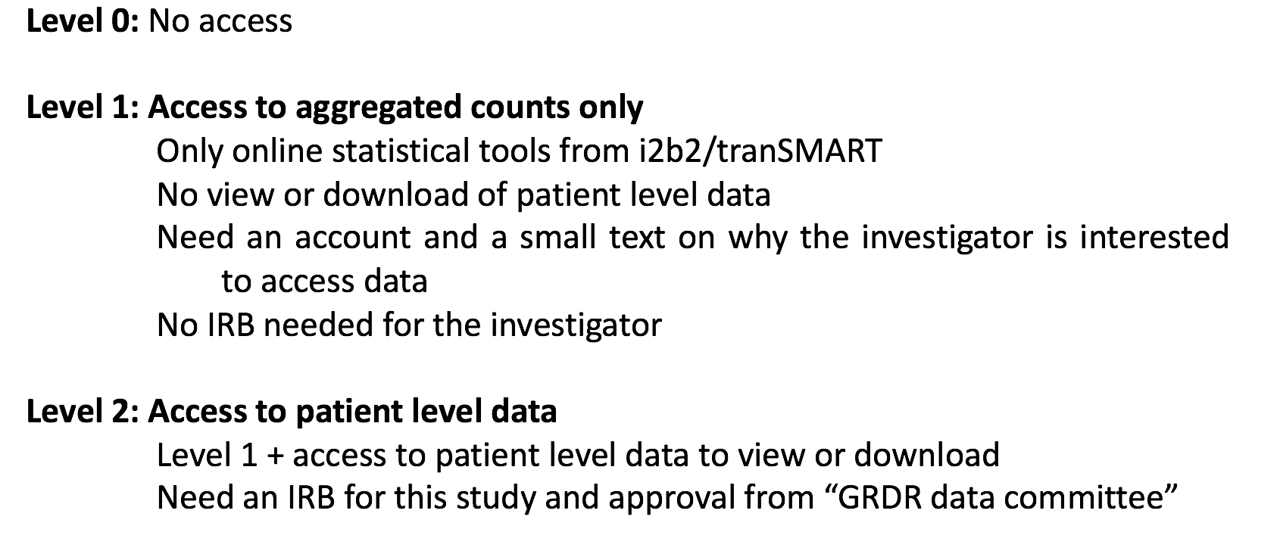

Fig 2: Access control levels from GRDR i2b2/tranSMART user interface

**IV. Data loading into i2b2/tranSMART**

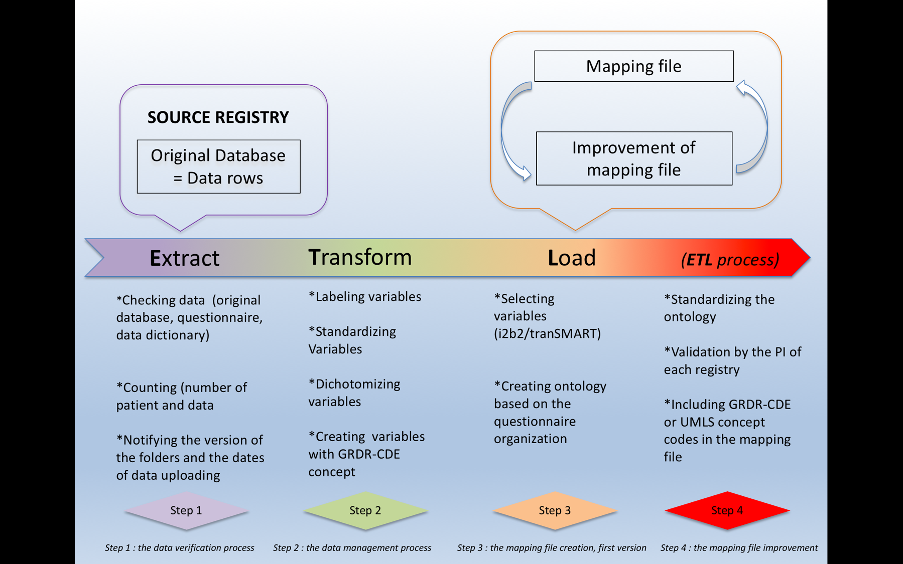

Fig 3: ***ETL*** *process*: data from source registry to i2b2/tranSMART

# **V. Guide for using the statistical tool of i2b2/tranSMART**

The “home page” is the primary interface for data exploration and cohort formation.

This page is divided in 2 parts: the left part contains the tree ranked per registry and the right part reveals cohort select boxes (**Subset 1** and **Subset 2**).

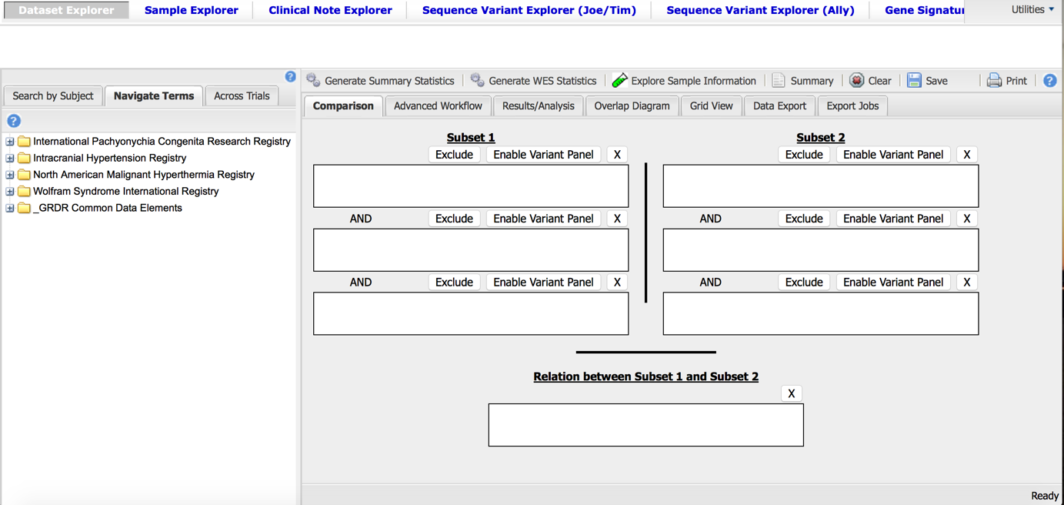

Fig 4: “Home page”

Each registry appears as a top node followed by a meta folder “_GRDR Common Data Elements” (Fig 5)

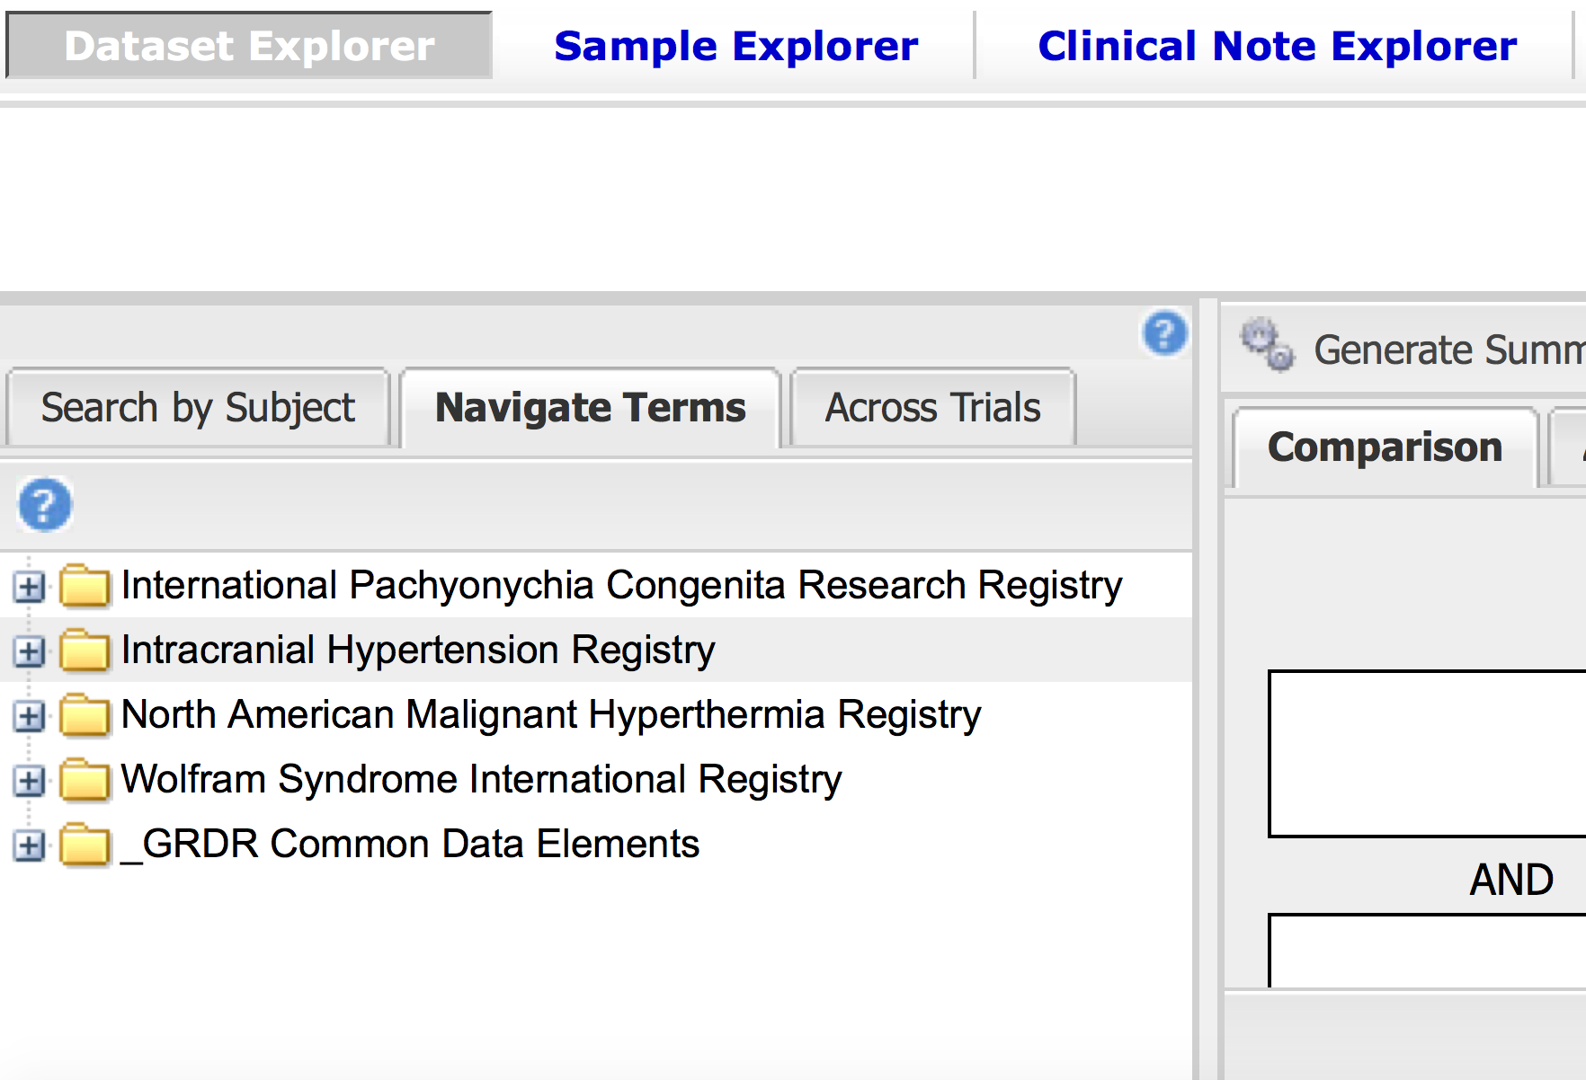

Fig 5: Left part of the “home page”: tree ranked per registry

All GRDR CDEs mapping from each registry is then automatically aggregated in the fifth folder (Fig 6)

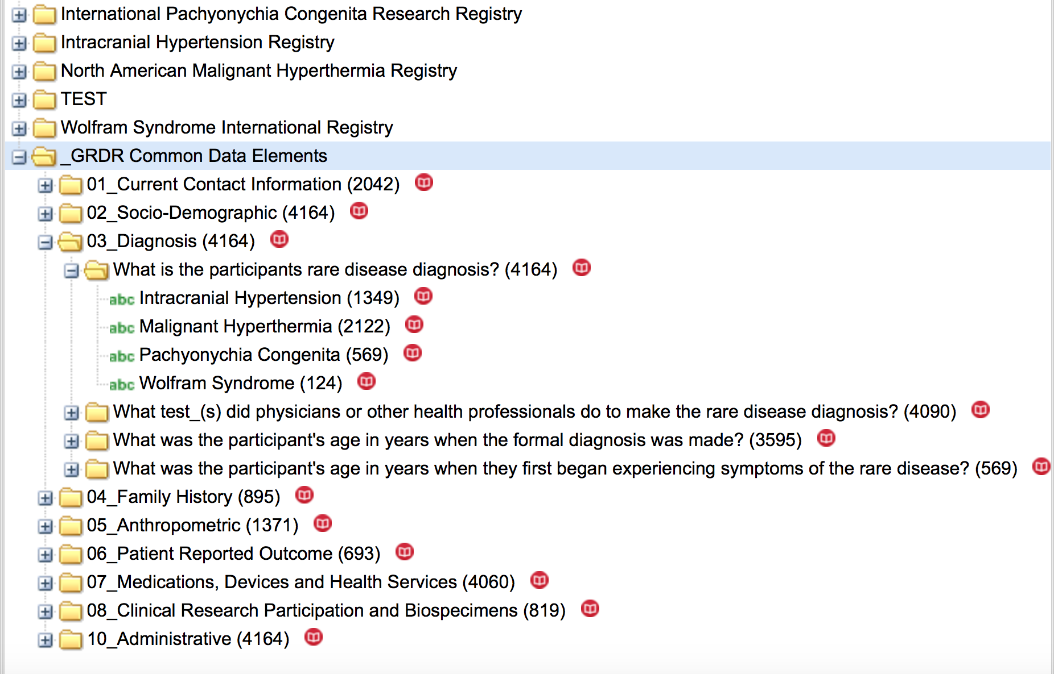

Fig 6: “_GRDR Common Data Elements” folder

In the spirit of facilitating the navigation in data in a registry and between registries but also in order to facilitate the research, the ontology for each registry is organized in the same way.

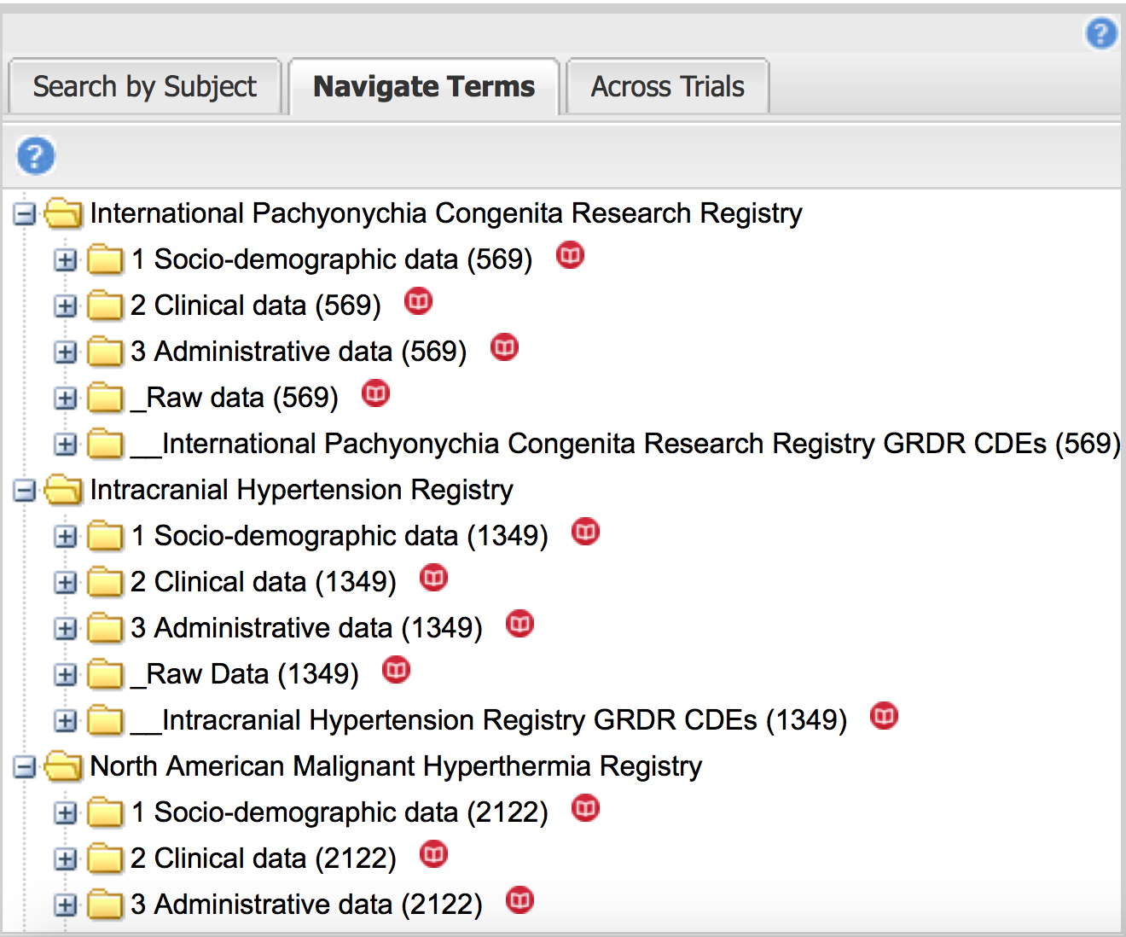

Fig 7: Registry data organization

For each a registry, we keep the same organization to rank data (Fig 7)

**For example:**

**“Intracranial Hypertension Registry” Folder** contains (Fig 8 ):

1. A grouping of **ALL variables** into a common classification:
   1. Socio-demographic data
   2. Clinical data
   3. Administrative data
2. RAW data as it was collected by the registry
3. Mapping to GRDR common data elements (**61 variables only) Folder called: “__Intracranial Hypertension Registry GRDR CDEs”**

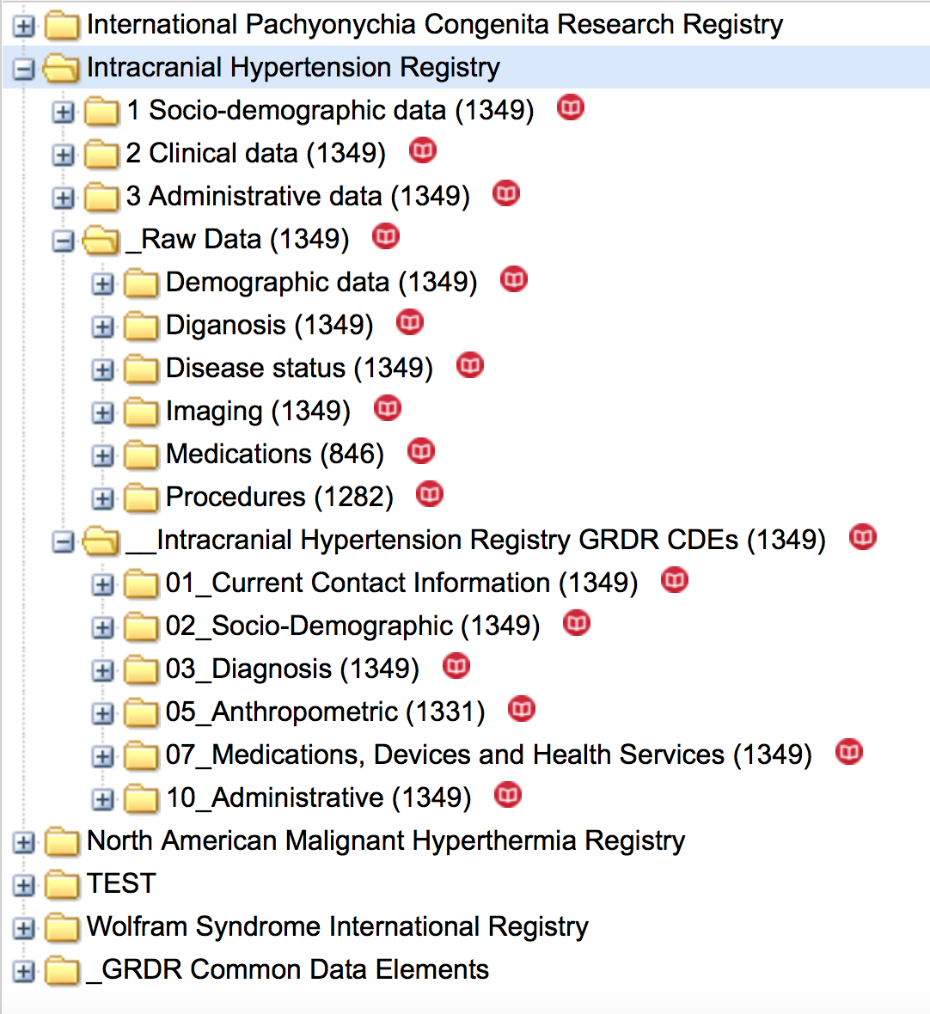

Fig 8: “Intracranial hypertension registry” folder

“2 Clinical data” is divided in 9 following the structure of usual medical report (consultation, hospitalization) (Fig 5).

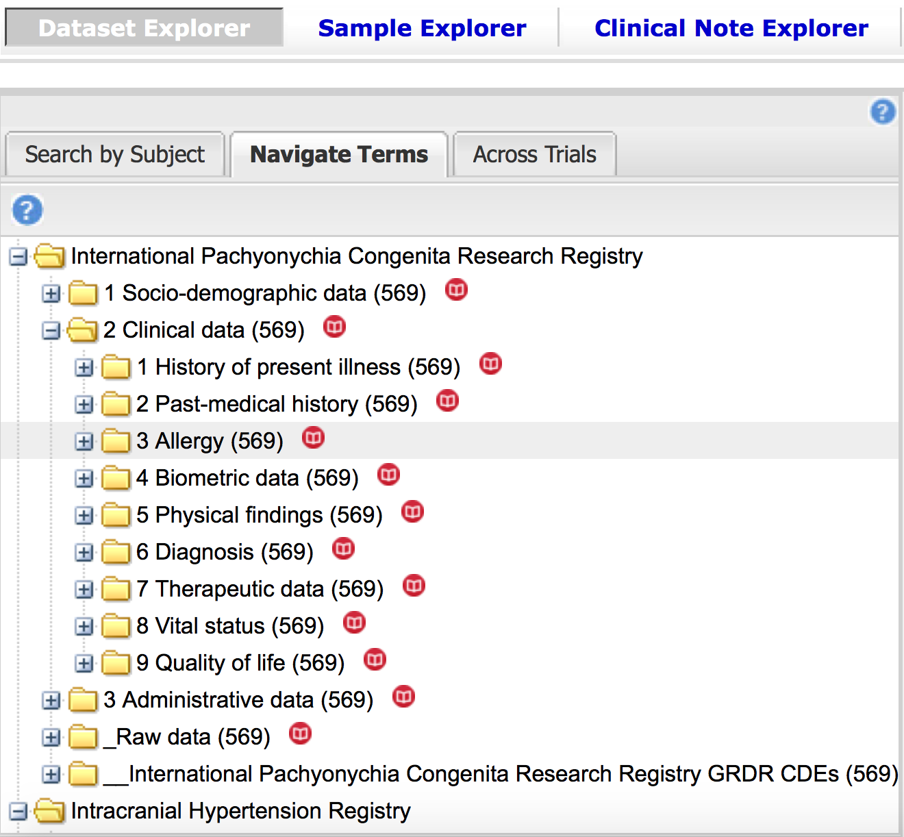

Fig 9: 2 Clinical data folder

Boxes to select patient are localized on the right part of the “home page”

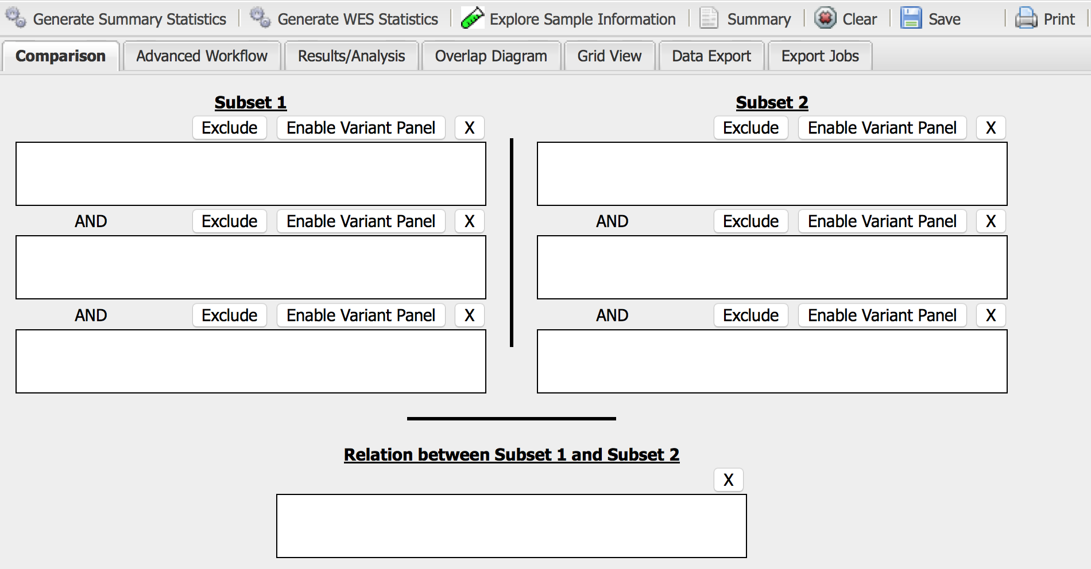

Fig 10: Right part of the “home page”: subsets selection

## A. GENERATE SUMMARY STATISTICS

First step: Select the cohort patients into the subsets, **subset 1** and **subset 2**.

Subset selection criterion can be quite complex, using combinations of the logical “and” (entries in stacked subset boxes), “or” (entries in the same subset box), “not” (by clicking the “exclude” option for the contents of a box).

*For example, IHR: patient with primary intracranial hypertension “primary” in subset 1 and patients with secondary or undetermined intracranial hypertension: “secondary” and “undetermined” in one box in subset 2.*

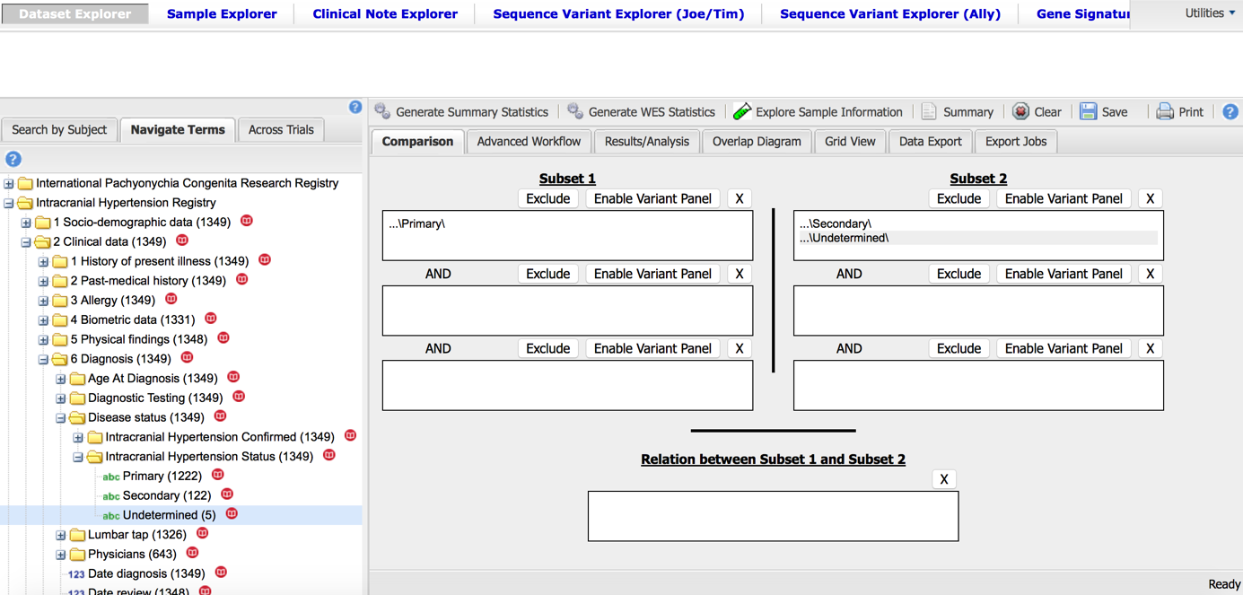

Fig 11: Subsets selection

Second step: click on “generate summary statistics”

On the top of “summary statistics”, you can verify query's summaries for Subset 1 and 2.

i2b2tranSMART application generate automatically a table with subject totals and statistical analysis by age, sex and race for each subset, if data are available.

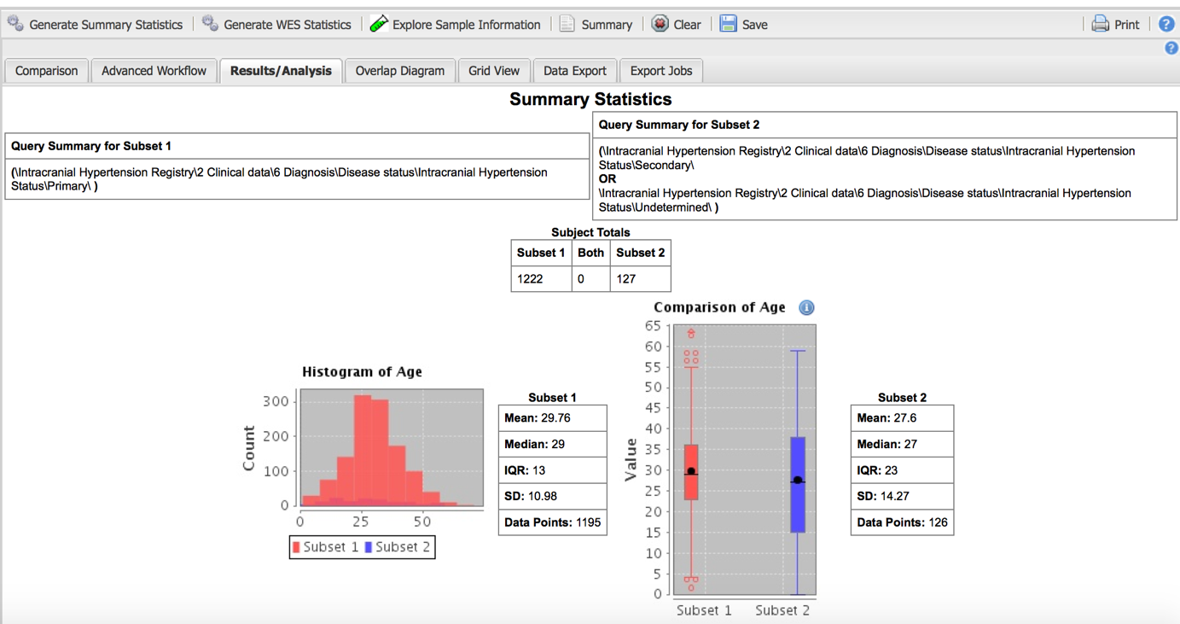

Fig 12: Summary statistics: subject totals and analysis with the variable age

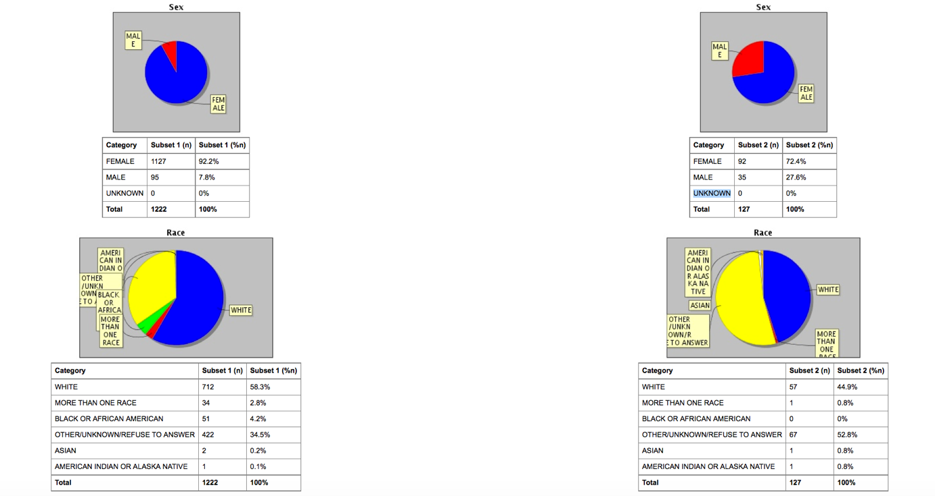

Fig 13: Summary statistics: statistical analysis with sex and race

Third step: “Drag” and “Drop” any of the variables (from left part to the right part of the home page) to generate statistical analysis.

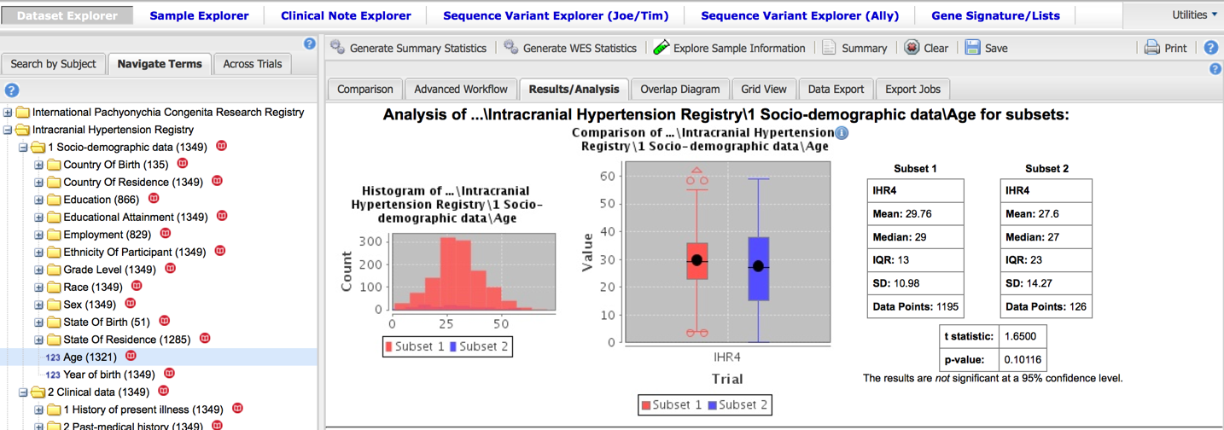

Fig 14: Analysis generated after dragging and dropping the variable “age”

## B. ADVANCED WORKFLOW

First step: Select the cohort patient into the **subset 1** or **subset 1** and **2** (depending the analysis)

Some of more advanced analytical workflows require two cohorts to be identified.

Second step: Click on “Advanced Workflow” and select the type of analysis.

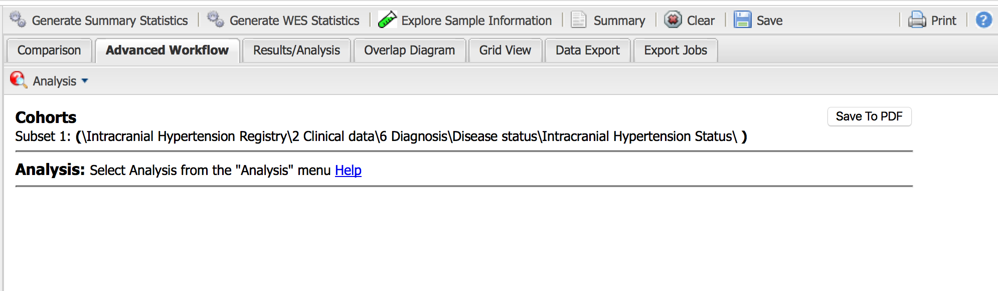

Fig 15: Advanced workflow

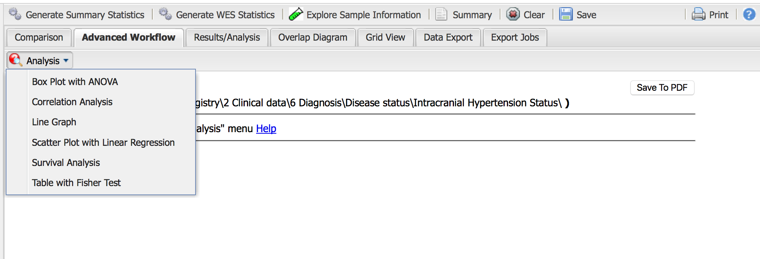

Fig 16: Advanced workflow: analysis

You have 6 choices:

- Box plot with ANOVA,

- correlation analysis (Spearman, Pearson, Kendall),

- line graph (mean with error bar, mean with standard deviation, median with error bar),

- scatter plot with linear regression,

- survival analysis,

- table with Fisher test.

Third step: select independent variable and dependent variable (you can transform a categorical variable into a continuous variable and vice versa). Concerning the ”Correlation analysis” option, variables are dragging and dropping into one box.

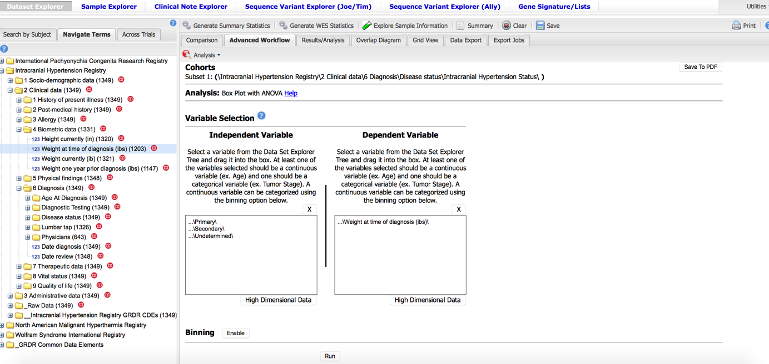

Fig 17: Select variables

If you click on binning: “enable “you can transform variable from this start point

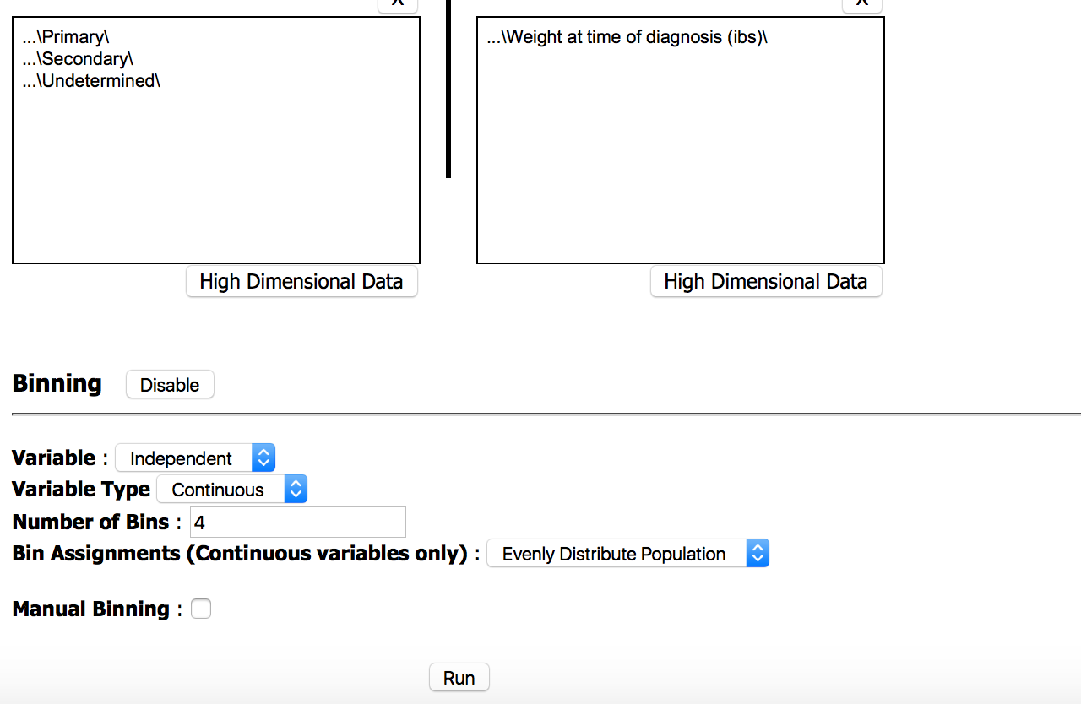

Fig 18: “Binning” interface

Fourth step: click on “run”

Results of the analysis appear in a different window with boxplot and table for ANOVA analysis.

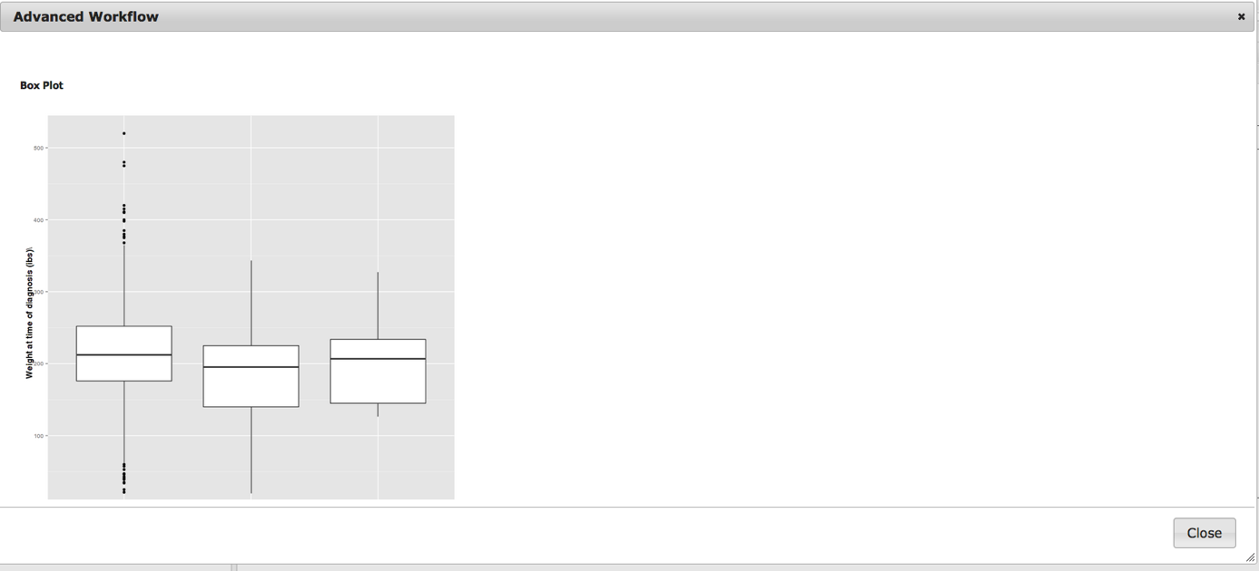

Fig 19: Advanced workflow: Box plot

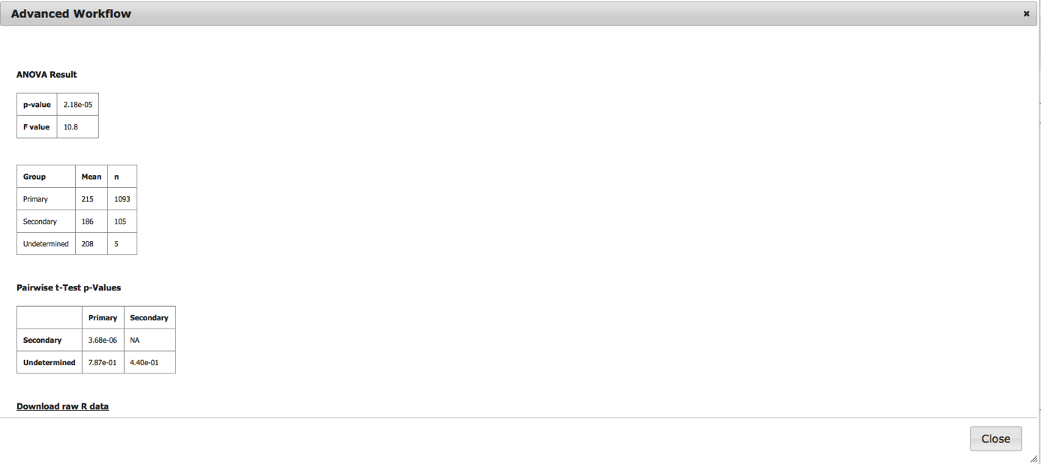

Fig 20: Advanced workflow: ANOVA result (you can export Raw R data if you are Level 2 data access)

## C. DATA EXPORT (Level 2 data access only)

To view and export clinical data from selected cohorts, click “Grid view” after generating summary statistics. A flexible table will be generated with all subjects defined by the cohorts, along with associated clinical data.

You can deselect any column and remove it from the table through the use of a dropdown menu available in the column headers. Subsets of rows or the entire data table can be exported as an excel compatible table by clicking the export button at the bottom of the page.

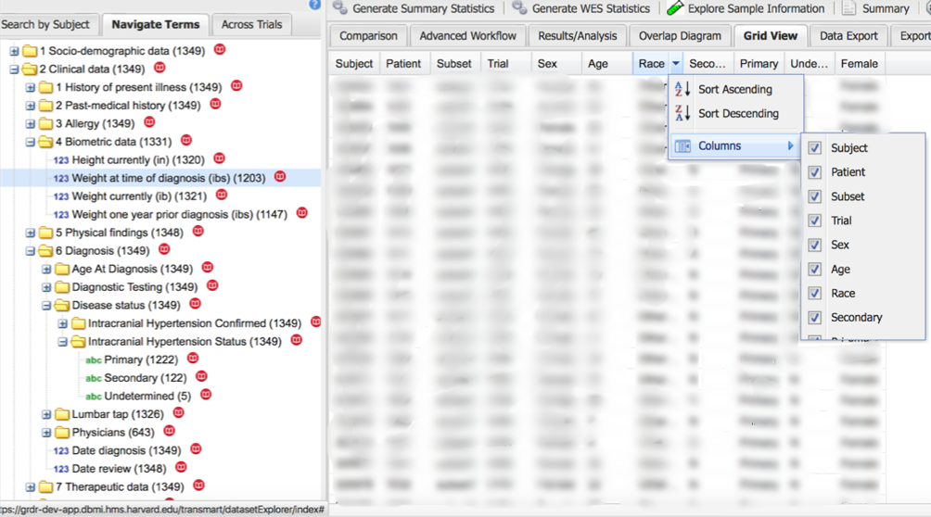

Fig 21: Grid view and column editing

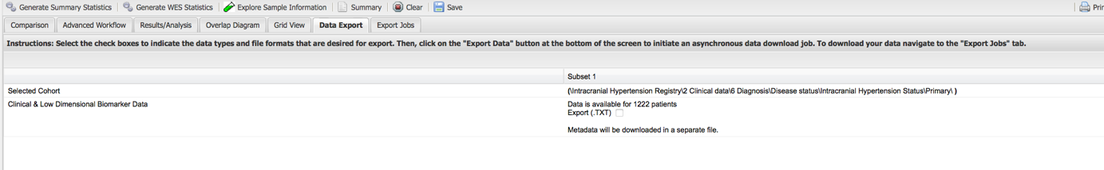

Fig 22: Data export interface

# **VI. Examples of statistical analysis for each registry**

## A. INTRACRANIAL HYPERTENSION REGISTRY (IHR)

### Generate summary statistics

**1- Is there an association between “Sex” and “Idiopathic Intracranial Hypertension”?(1)**

**Subset 1** = …\Primary\ (2 Clinical data\6 Diagnosis\Disease status\Intracranial hypertension status\Primary)

**Subset 2** = …\Secondary\ (2 Clinical data\6 Diagnosis\Disease status\Intracranial hypertension status\Secondary) **or** …\Undetermined\ (2 Clinical data\6 Diagnosis\Disease status\Intracranial hypertension status\Undetermined)

**

Fig 23: Subsets selection

Click on Generate Summary Statistics

Then “drag” and “drop” the variable *Sex*

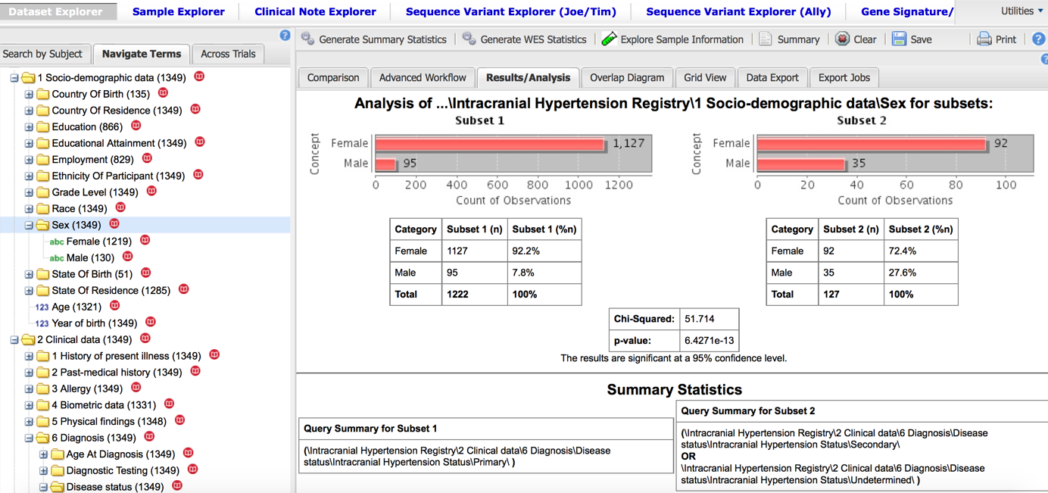

Fig 24: Result of Chi-squared test, (p<0,0001) 92,2% female in primary intracranial hypertension group (subset 1) > 72,4% female in secondary or undetermined intracranial hypertension group (subset 2)

**2-Is there an association between “Overweight” and “Idiopathic Intracranial Hypertension” among “female”?(1)**

**Subset 1** = …\Primary\ (2 Clinical data\6 Diagnosis\Disease status\Intracranial hypertension status\Primary)

**and** “Female” (\1 Socio-demographic\Sex\Female)

**Subset 2 =** …\Secondary\ (2 Clinical data\6 Diagnosis\Disease status\Intracranial hypertension status\Secondary) **or** …\Undetermined\ (2 Clinical data\6 Diagnosis\Disease status\Intracranial hypertension status\Undetermined)) **and** “Female” (\1 Socio-demographic\Sex\Female)

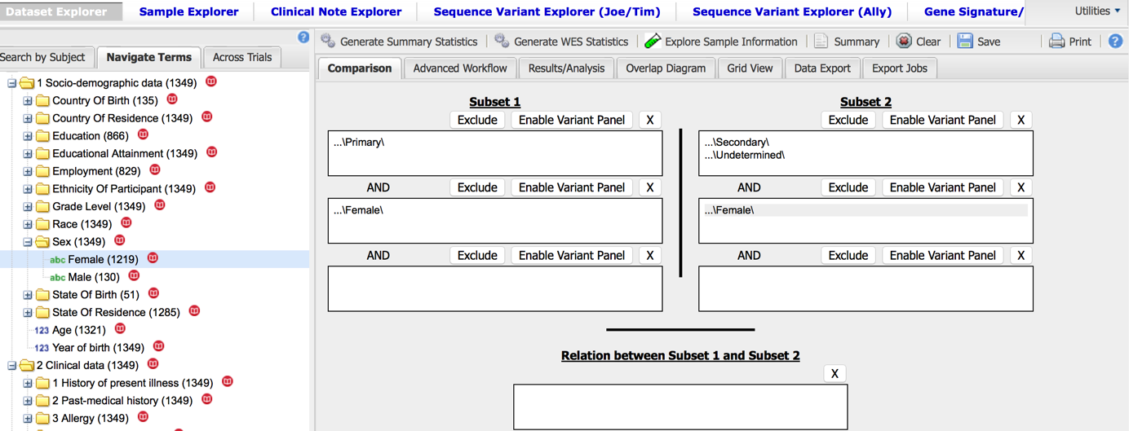

Fig 25: Subsets selection

Click on Generate Summary Statistics

Then “drag” and “drop” the variable *weight at time of diagnosis ibs*

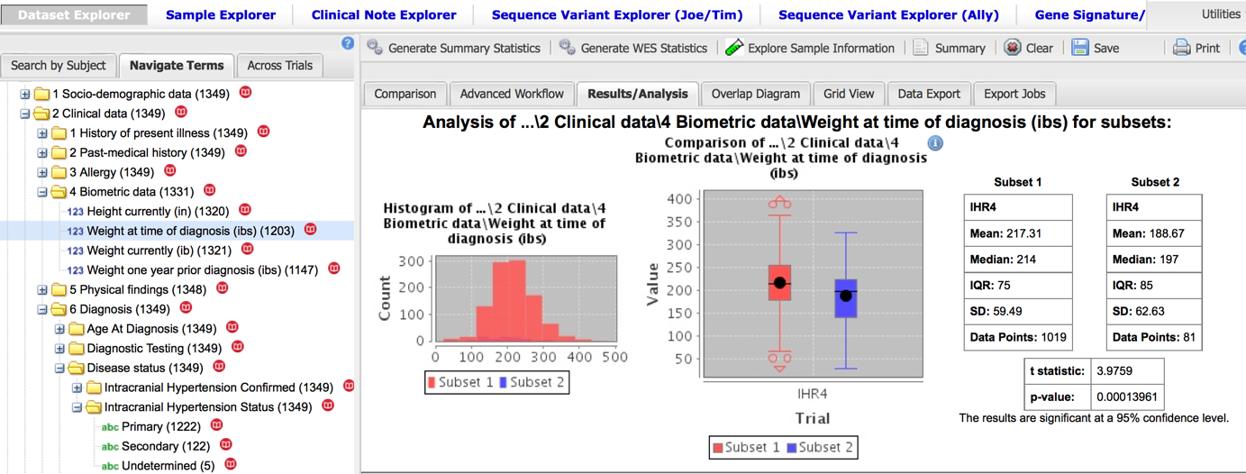

Fig 26: Result of t- test (Student), (p=0,0001) the mean “217,31” female with primary intracranial hypertension group (subset1) > The mean “188,67” female with secondary or undetermined intracranial hypertension group (subset2).

**3-Is there an association between “Headache” and “high LEVEL OF intracranial pressure”?**

**Subset 1** = …\Yes\ (2 Clinical data\5 Physical findings\Signs\Neurological signs\Headache\Yes)

**Subset 2 =** …\No\ (2 Clinical data\5 Physical findings\Signs\Neurological signs\Headache\No)

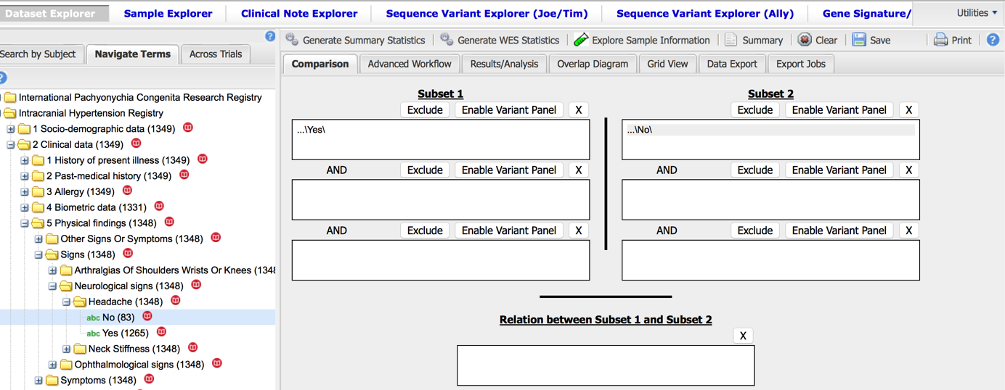

Fig 27: Subsets selection

Click on Generate Summary Statistics

Then “drag” and “drop” the variable *TAP1 pressure*

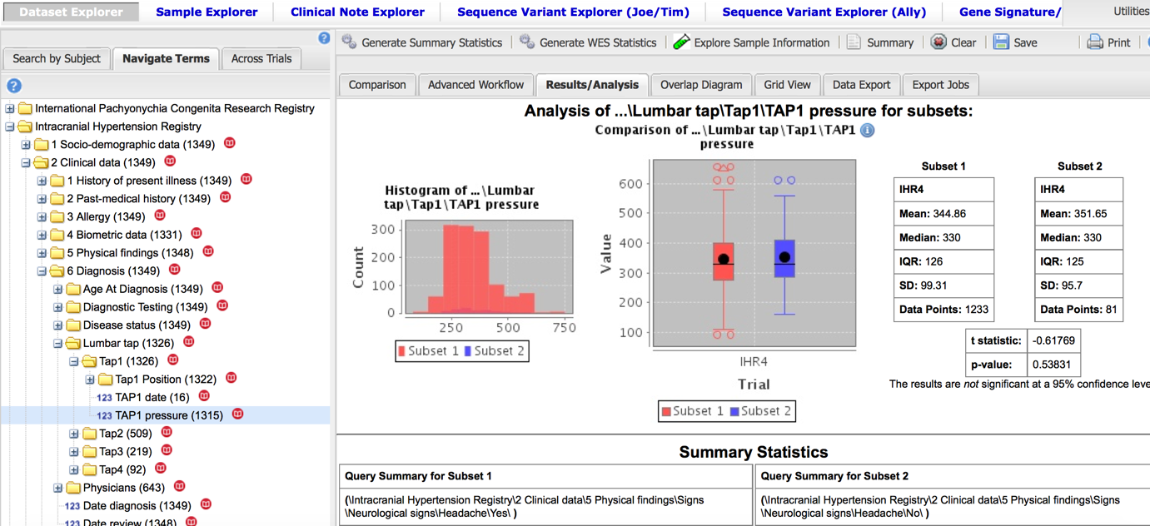

Fig 28: Result of t-test (Student), p>0,05.

**4-Is there an association between “Papilledema” and “high LEVEL OF intracranial pressure”?(2)**

**Subset 1** = …\Yes\ … (\2 Clinical data\5 Physical findings\Symptoms\Ophthalmological symptoms\Papilledema\Having papilledema \Yes)

**Subset 2 =** …\No\ (\2 Clinical data\5 Physical findings\Symptoms\Ophthalmological symptoms\Papilledema\Having papilledema \No)

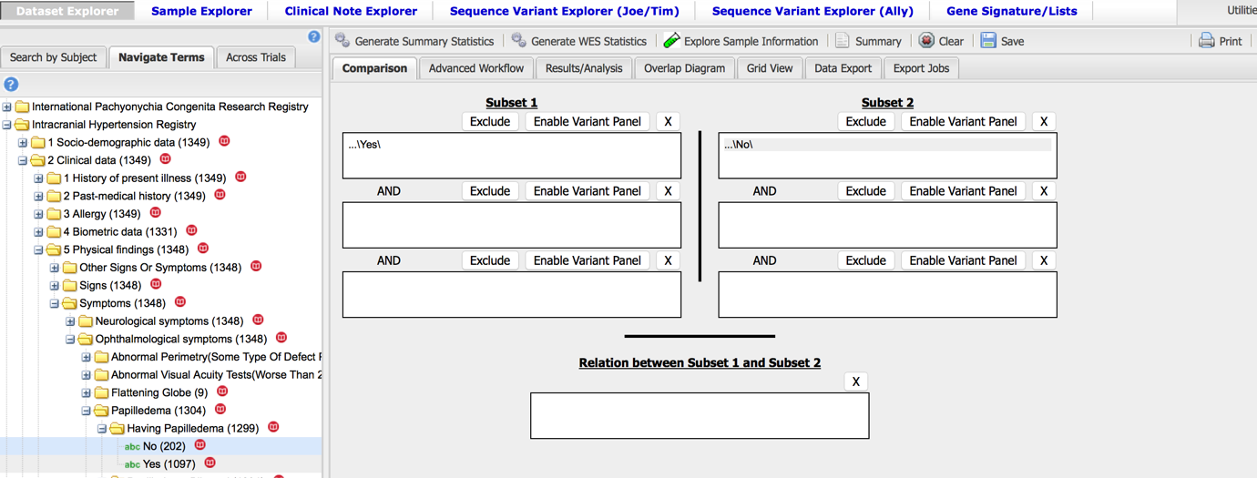

Fig 29: Subsets selection

Click on generate summary statistics

Then “drag” and “drop” the variable *TAP1 pressure*

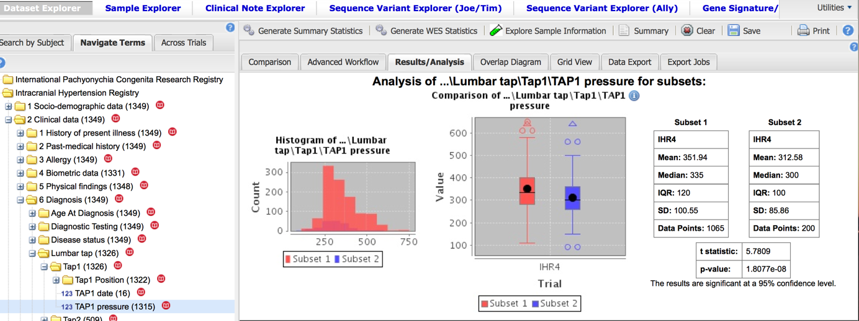

Fig 30: Result of t-test, p< 0,0001

For the TAP1 pressure the mean “351,94” in the group Papilledema Yes (subset1) > the mean “312,58” Papilledema “No”( subset 2).

### Advanced workflow

**- Is there an association between “Papilledema” and “high LEVEL OF intracranial pressure”?(2)**

**Subset 1** = …\Papilledema\ (\2 Clinical data\5 Physical findings\Symptoms\Ophthalmological symptoms\Papilledema\)

Then click on **Advanced Workflow**

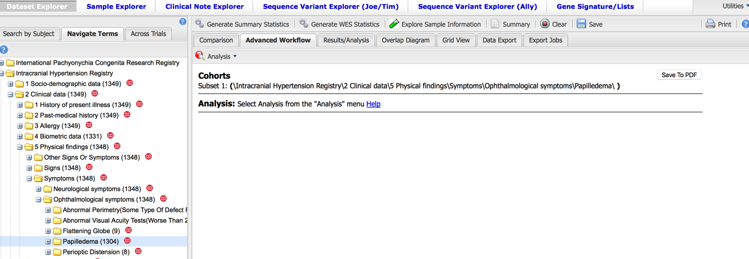

Fig 31: Cohort and analysis selection

Click on **Analysis** and select Box plot with ANOVA

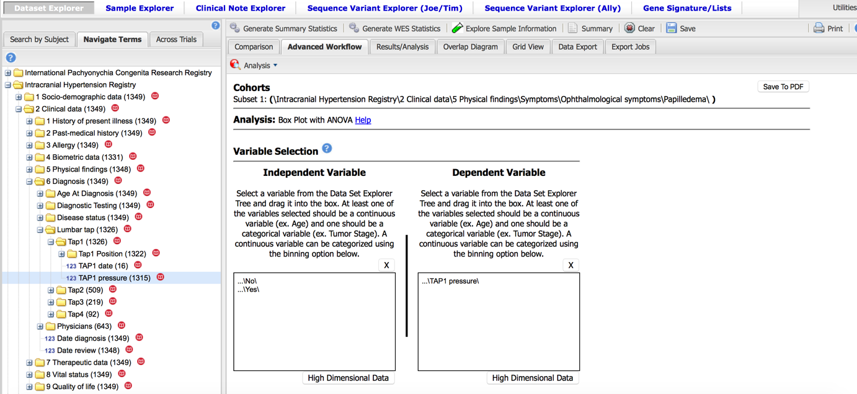

Fig 32: Variables selection for Box plot ANOVA

**Independent variable** = …\ Having Papilledema\ (\2 Clinical data\5 Physical findings\Symptoms\Ophthalmological symptoms\Papilledema\Having papilledema)

**Dependent variable**= …\TAP1 pressure\ (2 Clinical data\6 Diagnosis\Lumbar tap\TAP1\TAP1 Pressure)

Then click on **Run**

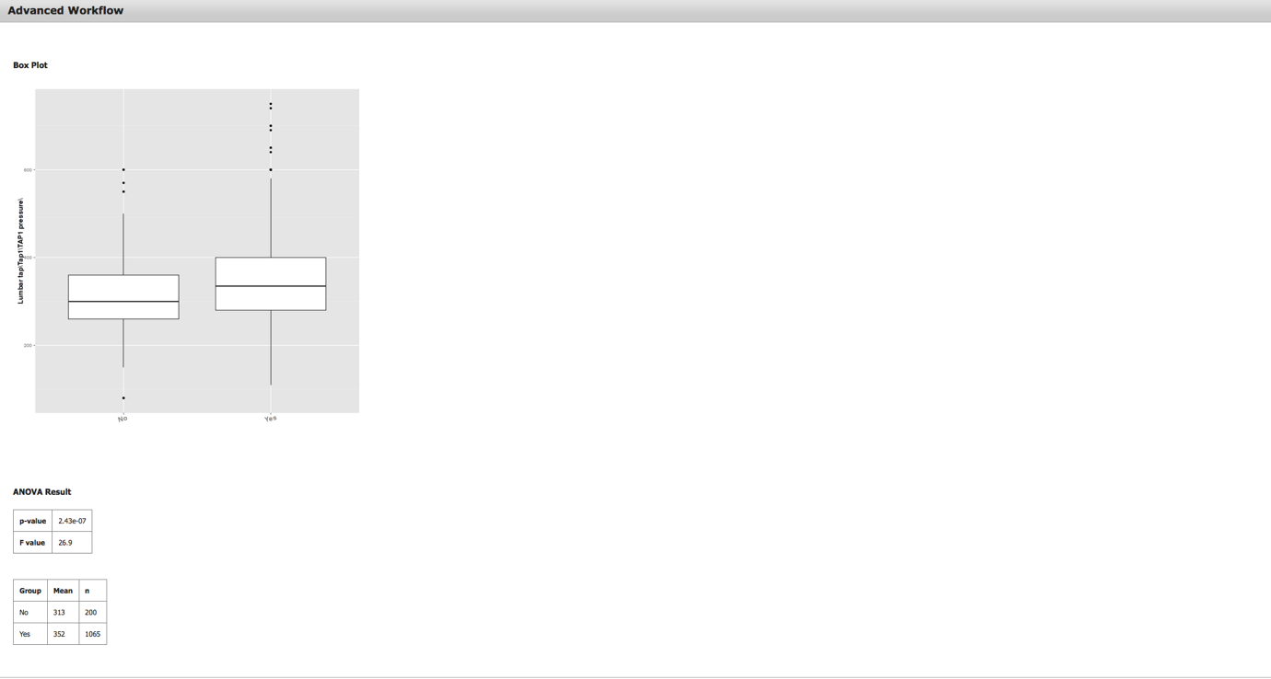

Fig 33: Advanced Workflow results (Box plot with ANOVA), p< 0,0001.

## B. INTERNATIONAL PACHYONYCHIA CONGENITA RESEARCH REGISTRY (IPCRR)

### Generate summary statistics

**1- Do P.C. patients with different gene mutations have different phenotypes?(3)**

**Subset 1** = …\Krt6a\ (2 Clinical data\6 Diagnosis\Mutation in the gene for Keratin\Krt6a)

**Subset 2 =** …\Krt16\ (2 Clinical data\6 Diagnosis\Mutation in the gene for Keratin\Krt16)

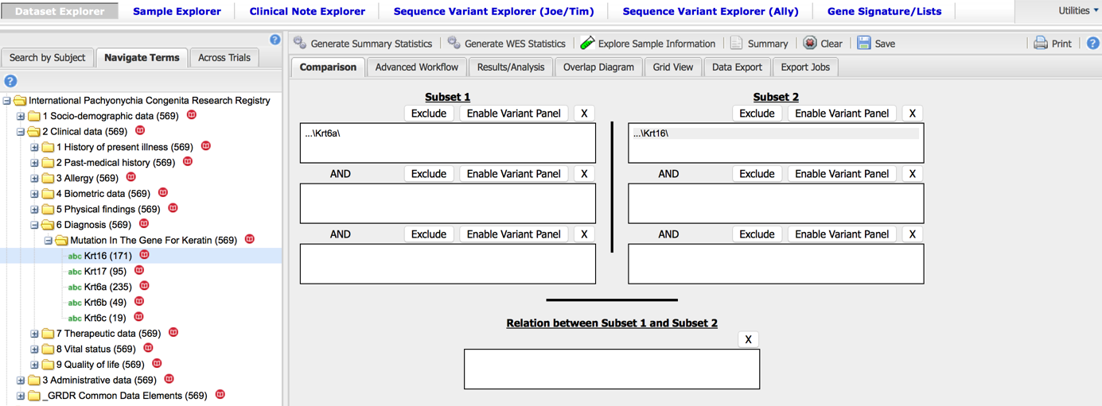

Fig 34: Subsets selection

Click on generate summary statistics

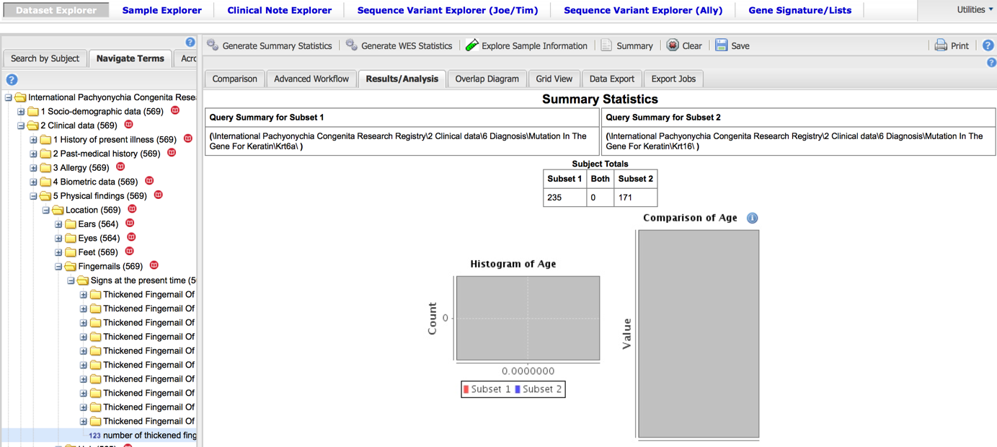

Fig 35: Summary statistics: “Age “is missing for this registry

Then “drag” and “drop” the variable *Number of thickened fingernails at this time*

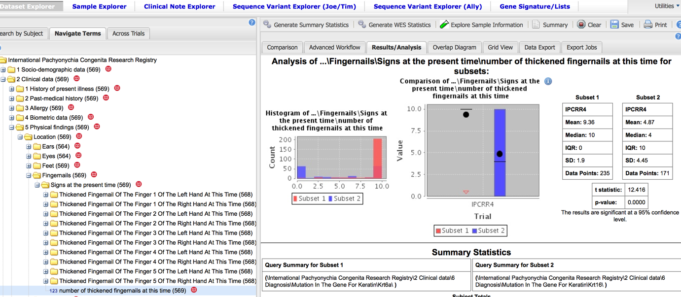

Fig 36: t-test, p< 0,0001, mean of *Number of thickened fingernails at this time* in patient withKrt6A mutation group (subset 1) > mean of *Number of thickened fingernails at this time* in patient withKrt16 mutation group (subset 2).

**2- What is the impact of the thickened fingernails on the daily life or activities?(3)**

**Subset 1** = …\Always a problem but able to function\ **or** …\Sometimes create a problem\ **or** …\Thickened fingernails make it impossible to function\ (2 Clinical data\9 Quality of life\Location\Impact on the daily life\Impact of the thickened fingernails on the daily life or activities\...)

**Subset 2 =** …\No impact\ (2 Clinical data\9 Quality of life\Location\Impact on the daily life\Impact of the thickened fingernails on the daily life or activities\...)

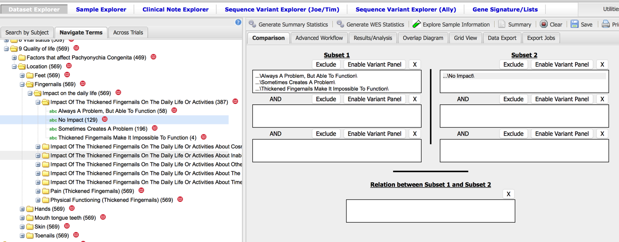

Fig 37: Subsets selection

Click on generate summary statistics

Then “drag” and “drop” the variable *Number of thickened fingernails at this time*

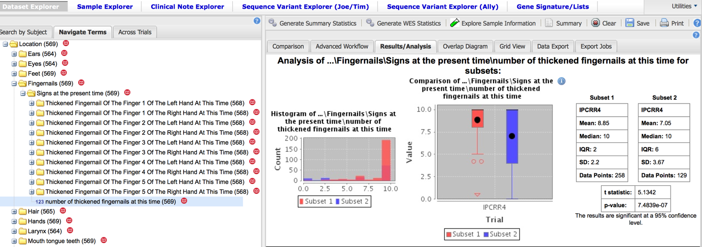

Fig 38: t test p value < 0.0001

The mean “8.85” thickened fingernails in the group “at least one impact” (subset1) > The mean “7.05” thickened fingernails in group “no impact” (subset2).

### Advanced workflow

**- Do P.C. patients with different gene mutations have different phenotypes?(3)**

**Subset 1** = …\Krt6a\ (2 Clinical data\6 Diagnosis\Mutation in the gene for Keratin\Krt6a) **or**

…\Krt16\ (2 Clinical data\6 Diagnosis\Mutation in the gene for Keratin\Krt16)

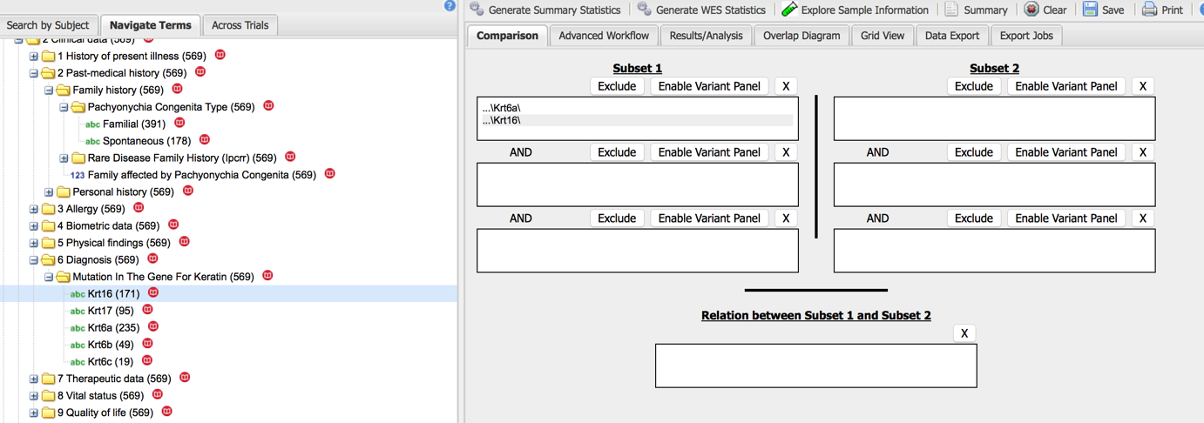

Fig 39: Cohort and analysis selection

Then click on **Advanced Workflow**

Click on **Analysis** and select Table with Fisher test

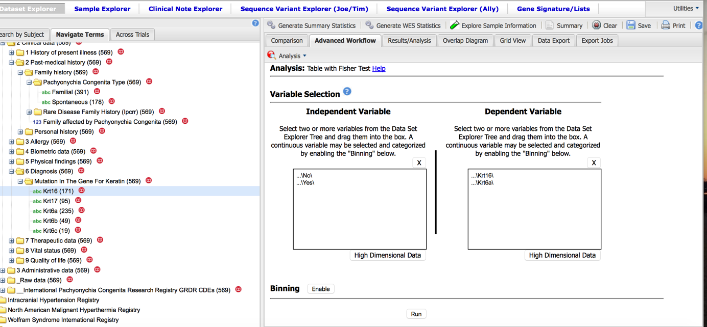

Fig 40: Variables selection (table with Fisher test)

**Independent variable** = …\Thickened White skin in mouth located under tongue\ (\2Clinical data\5 Physical findings\Location\Mouth tongue teeth\Precise location)

**Dependent variable**= …\Krt6a\ …\Krt16\ (2 Clinical data\6 Diagnosis\Mutation in the gene for Keratin)

Then click on **Run**

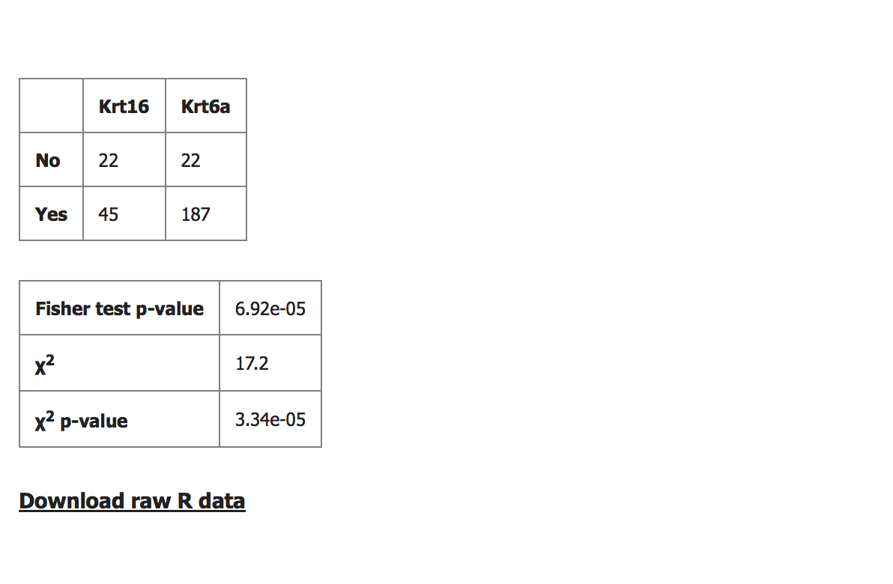

Fig 41: Fisher test p-value < 0,0001 *Thickened White skin in mouth located under tongue* isassociated with Krt6a.

## C. NORTH AMERICAN MALIGNANT HYPERTHERMIA REGISTRY (NAMHR)

### Generate summary statistics

**1- Is there any difference in the use of Dantrolene® between patient AKA (Already Known As MH susceptible) and others patients?**

**Subset 1** = …\Yes\ (2 Clinical data\2 Past medical history\Personal history\Is the patient known as AKA patient (patient already known as MH susceptible\Yes)

**Subset 2 =** …\No\ (2 Clinical data\2 Past medical history\Personal history\Is the patient known as AKA patient (patient already known as MH susceptible\No)

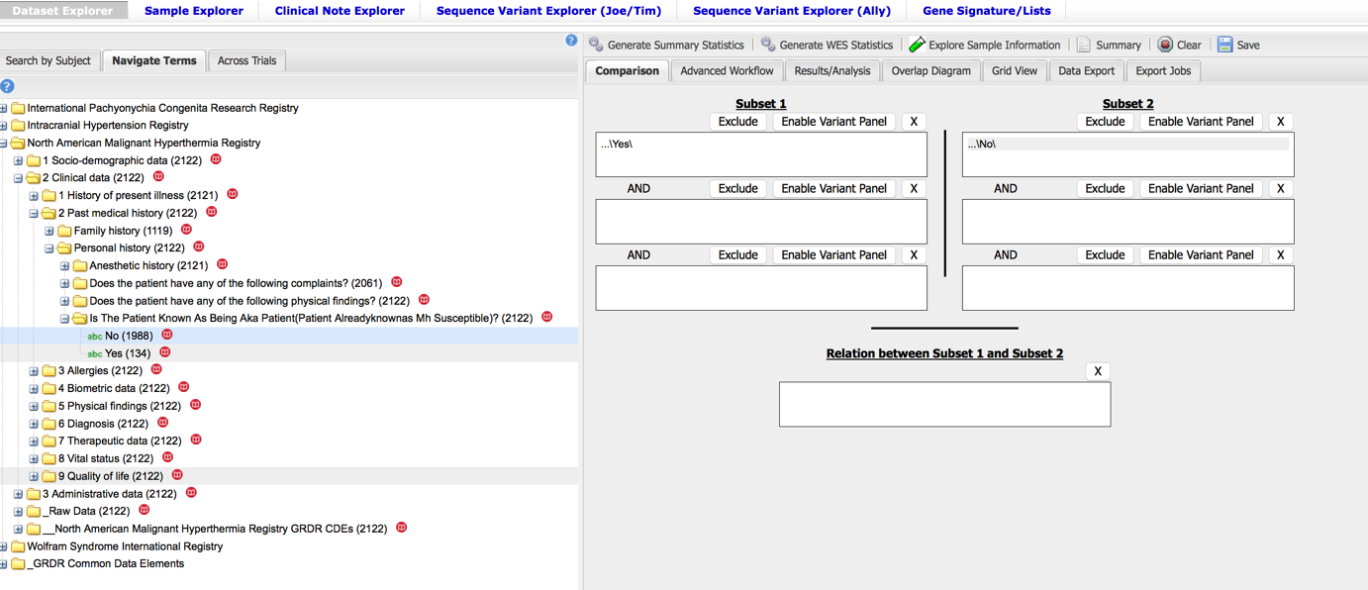

Fig 42: Subsets selection

Click on generate summary statistics

Then “drag” and “drop” the variable *Dantrolene given*

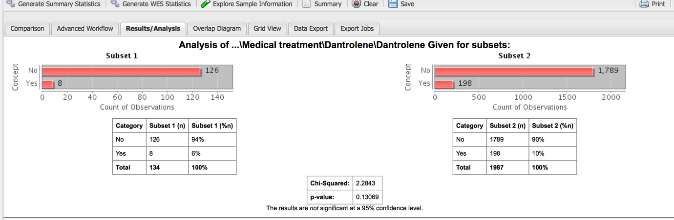

Fig 43: Chi-squared test: p>0,05

**2 - Does the patients with Succinylcholine are more involved in severe Malignant Hyperthermia incidents?**

**Subset 1** = …\Yes\ (2 Clinical data\1 History of present illness\Data of MH incident\2 Procedure \Drugs involved\Succinylcholine\IM succinylcholine\Yes) **or** …\Yes\ (2 Clinical data\1 History of present illness\Data of MH incident\2 Procedure \Drugs involved\Succinylcholine\IV succinylcholine\Yes)

**Subset 2 =** …\No\ (2 Clinical data\1 History of present illness\Data of MH incident\2 Procedure \Drugs involved\Succinylcholine\IM succinylcholine\No) **or** …\No\ (2 Clinical data\1 History of present illness\Data of MH incident\2 Procedure \Drugs involved\Succinylcholine\IV succinylcholine\No)

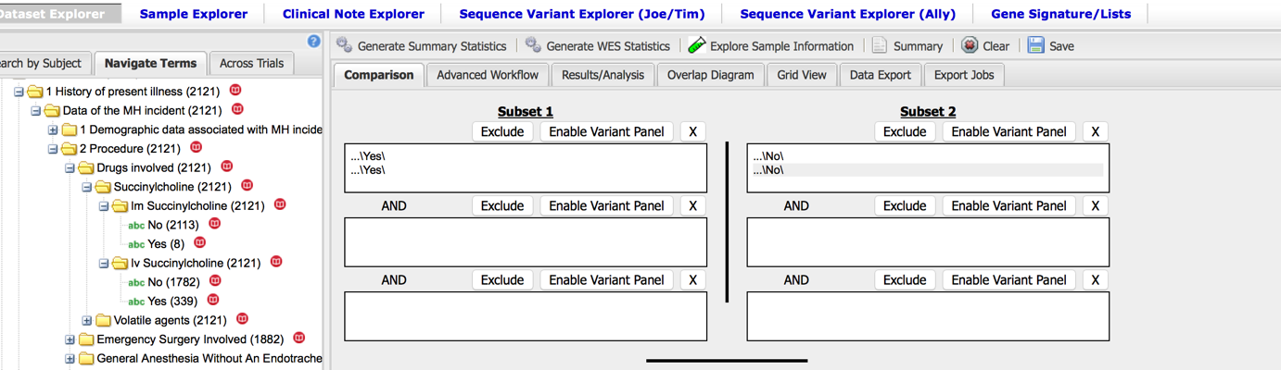

Fig 44: Subsets selection

Click on generate summary statistics

Then “drag” and “drop” the variable *Sinusal tachycardia*

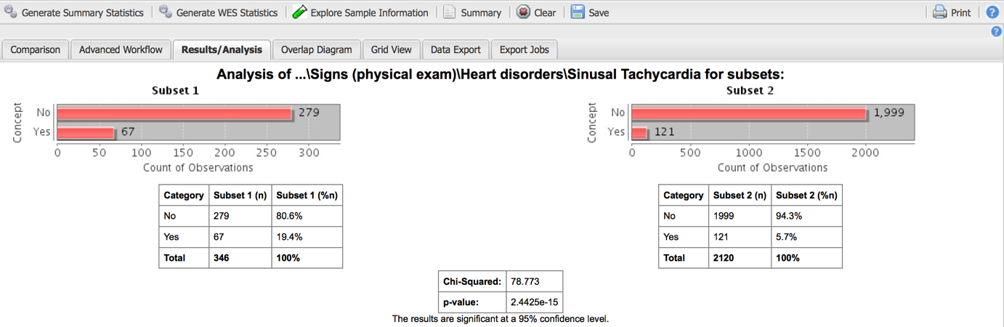

Fig 45: Chi squared test: p<0,05: patients with succinylcholine did more events of sinusal tachycardia.

Then “drag” and “drop” the variable *Ventricular tachycardia*

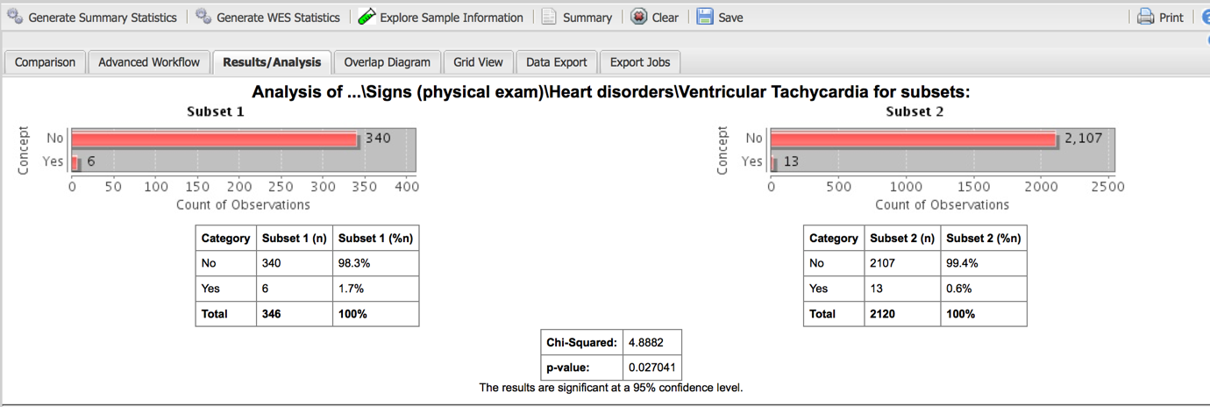

Fig 46: Chi squared test: p<0,05: patients with succinylcholine did more events of ventricular tachycardia

Then “drag” and “drop” the variable *Cardio pulmonary resuscitation*

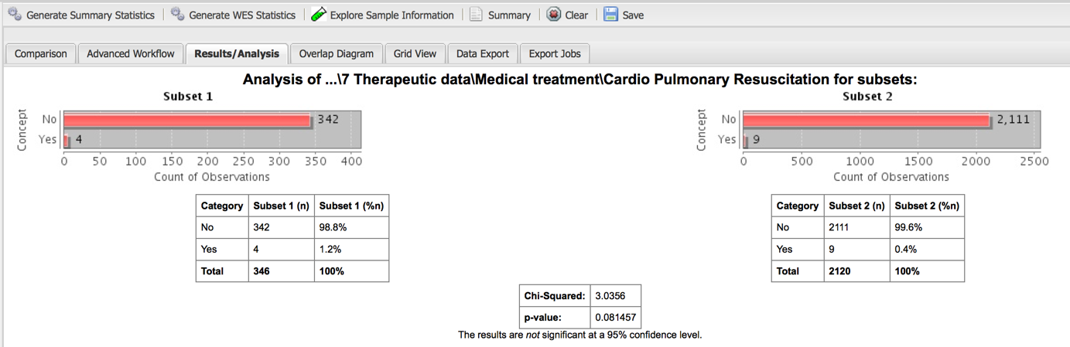

Fig 47: Chi squared test: p<0,05: patients with succinylcholine is associated with cardio pulmonary resuscitation.

### Advanced workflow

**-Is there a relation between *Most abnormal pH level* and *Most abnormal blood gas pCo2 (mmHg)*(biological exams of MH incident) ?(4)**

**Independent variable** = …\Most abnormal pH level \ (\6 Diagnosis\1 Biological exams\Most abnormal pH level)

**Dependent variable**= …\Most abnormal blood gas pCo2(mmHg) \ (\6 Diagnosis\1 Biological exams\Most abnormal blood gas pCo2(mmHg))

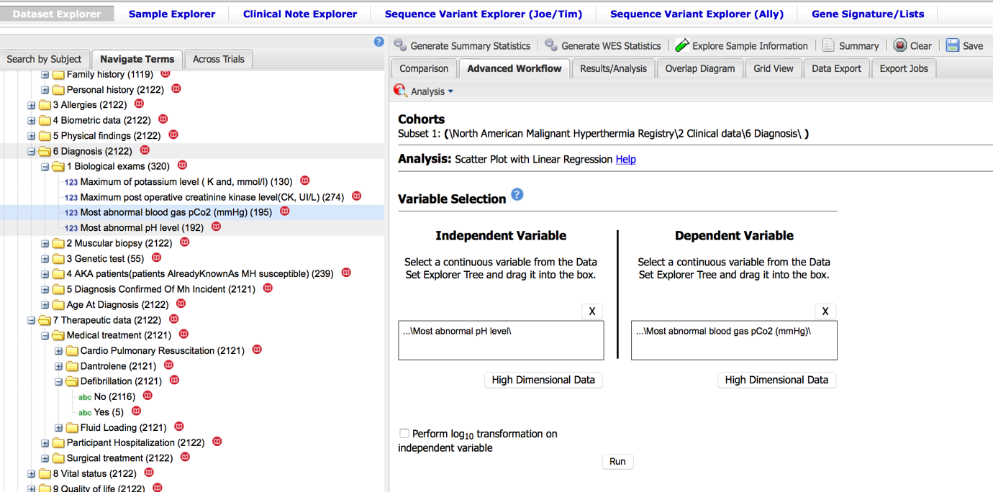

Fig 48: Variables selection for Scatter plot with linear regression.

Click on **Run**

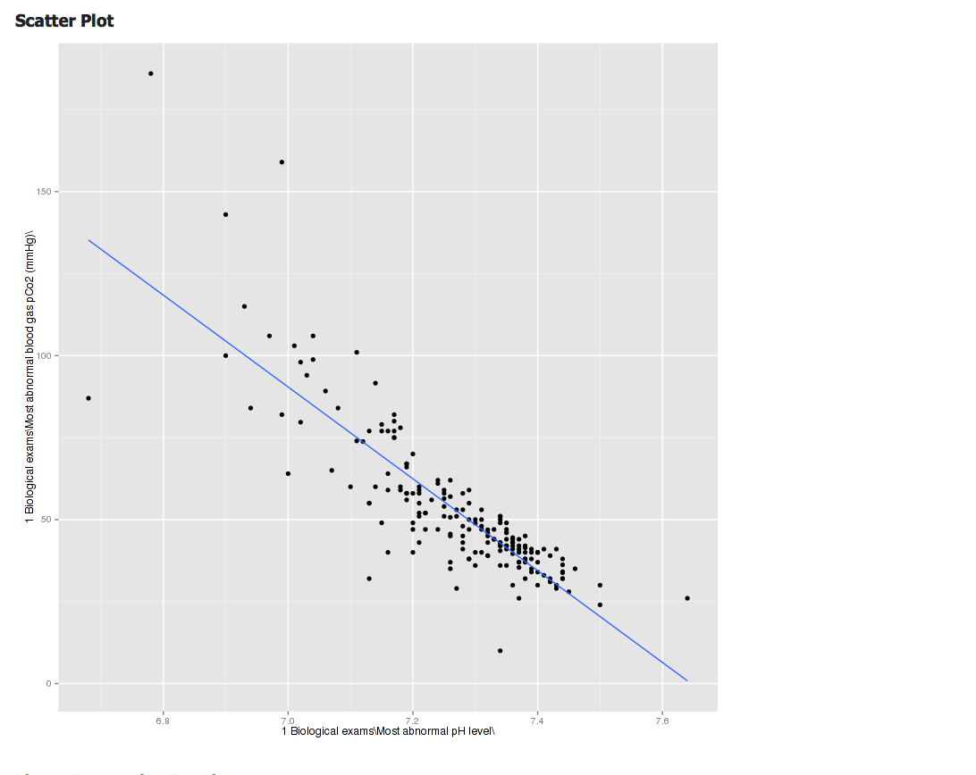

Fig 49: Scatter plot with linear regression line

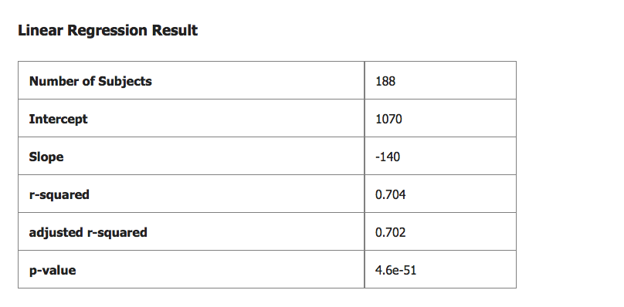

Fig 45: Linear regression results

## D. WOLFRAM SYNDROME INTERNATIONAL REGISTRY (WFS)

### Generate summary statistics

**-Is there any association between having diabetes mellitus and having atrophic optic nerve?(5)**

**Subset 1** = …\Yes\ (\2 Clinical data\5 Physical findings\Disorders\Diabetes mellitus\Having diabetes mellitus\Yes)

**Subset 2 =** …\No\ (\2 Clinical data\5 Physical findings\Disorders\Diabetes mellitus\Having diabetes mellitus\No) “**or**” …\Don’t know\ (\2 Clinical data\5 Physical findings\Disorders\Diabetes mellitus\Having diabetes mellitus\Don’t know)

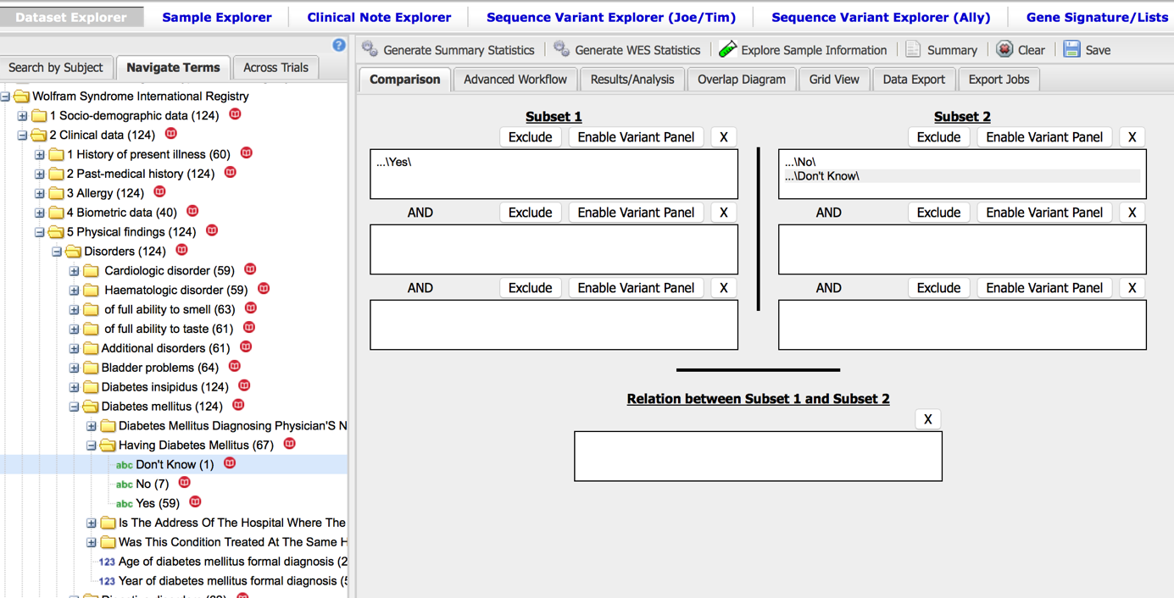

Fig 50: Subsets selection

Click on generate summary statistics

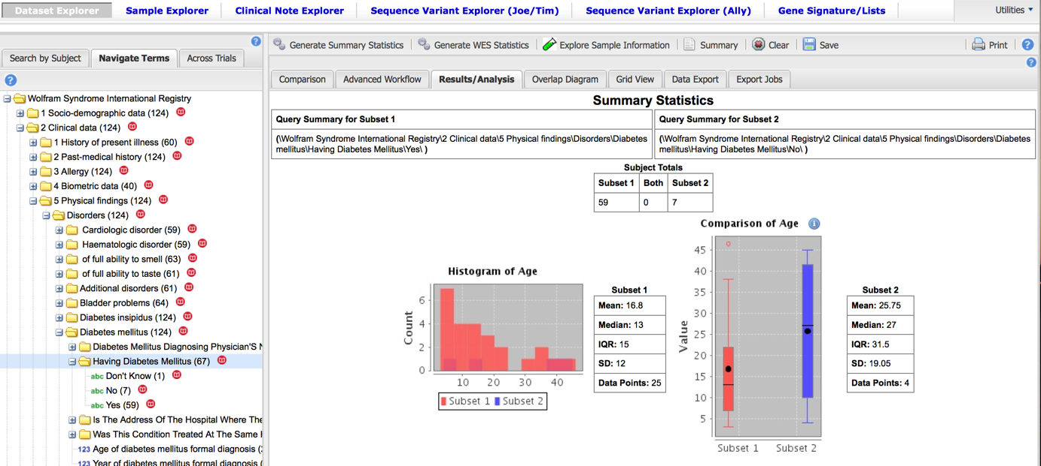

Fig 51: Summary statistics

Then “drag” and “drop” the variable *Having optic atrophy*

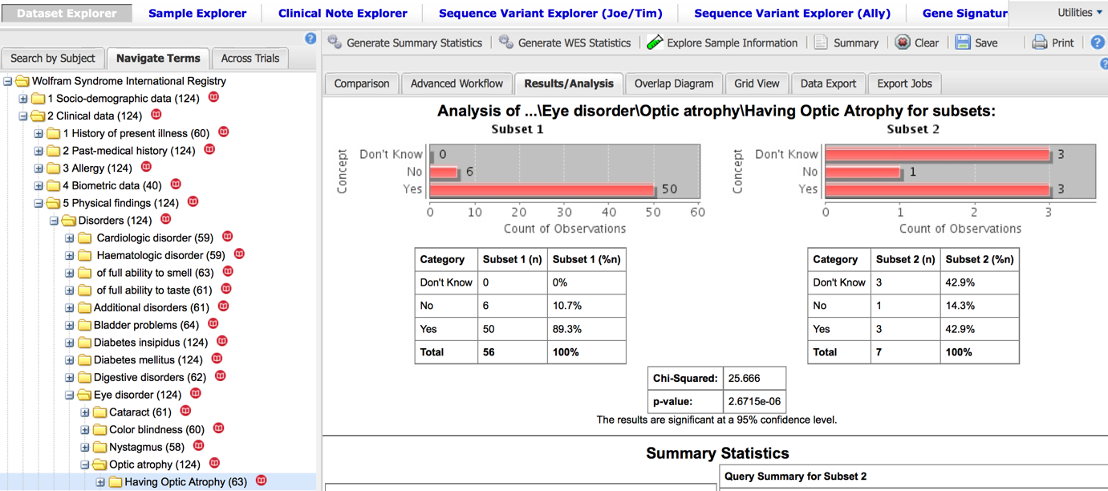

Fig 52: Chi- squared test, p< 0,0001.

### Advanced workflow

**- Is there a link between *weight currently* and *having hormonal disorders*?**

**Independent variable** = …\Most abnormal pH level \ (\6 Diagnosis\1 Biological exams\Most abnormal pH level)

**Dependent variable**= …\Most abnormal blood gas pCo2(mmHg) \ (\6 Diagnosis\1 Biological exams\Most abnormal blood gas pCo2(mmHg))

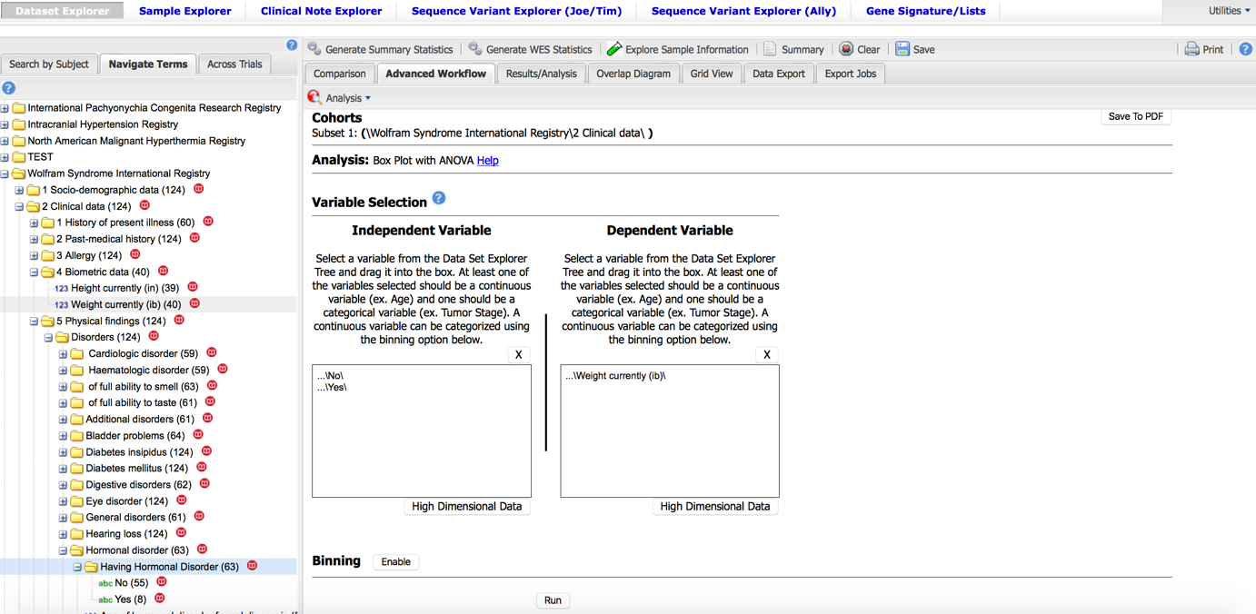

Fig 53: Subsets selection

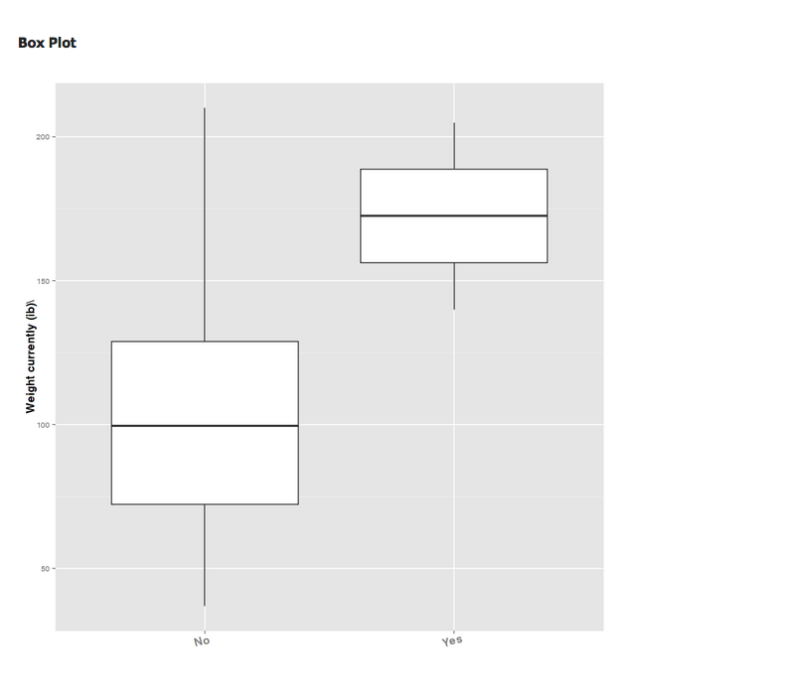

Fig 54: Box plot

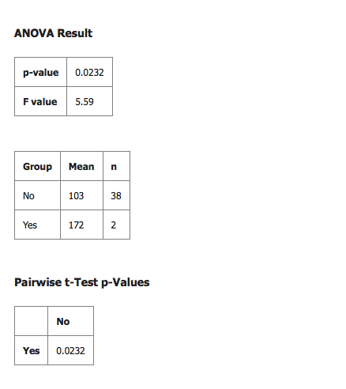

Fig 55: ANOVA results: p< 0,05, weight’s mean “172” in hormonal disorder group (subset1) > weight’s mean “103” in No hormonal disorder group (subset2).

# **VII. GRDR Common Data Elements**

## A. DEFINITION

CDEs enable information to be collected and presented in consistent formats to ensure data from different sources are defined in the same way using the same standards and vocabulary. A CDE consists of both a precisely defined question and a specified format or set of permissible responses.

Each CDE represents a variable that can be collected and analyzed in projects and registries within a particular analytic or clinical domain

GRDR® program staff have developed a [model registry of CDEs](https://ncats.nih.gov/files/GRDR-CDEs-5-2015.xlsx) (Excel - 48KB) for entry of patient data into any rare disease registry. The GRDR program CDEs include a subset of CDEs that do not include personal information that could identify the patient.

61 GRDR CDEs are organized into 10 categories that include required and optional elements:

* Current contact information
* Sociodemographic information
* Diagnosis
* Family history
* Birth and reproductive history
* Anthropometric (body measurement) information
* Patient-reported outcomes
* Medications, devices and health services
* Clinical research participation and biospecimen donation
* Communication and preferences

## B. STATISTICAL ANALYSIS USING GRDR CDEs

**- Is there an association between “Sex” and “Rare diseases diagnosis”?**

**Subset 1** = …\Female\ (\2 Socio-Demographic\What is the participant Sex\Female)

**Subset 2 =** …\Male\ (\2 Socio-Demographic\What is the participant Sex\Male)

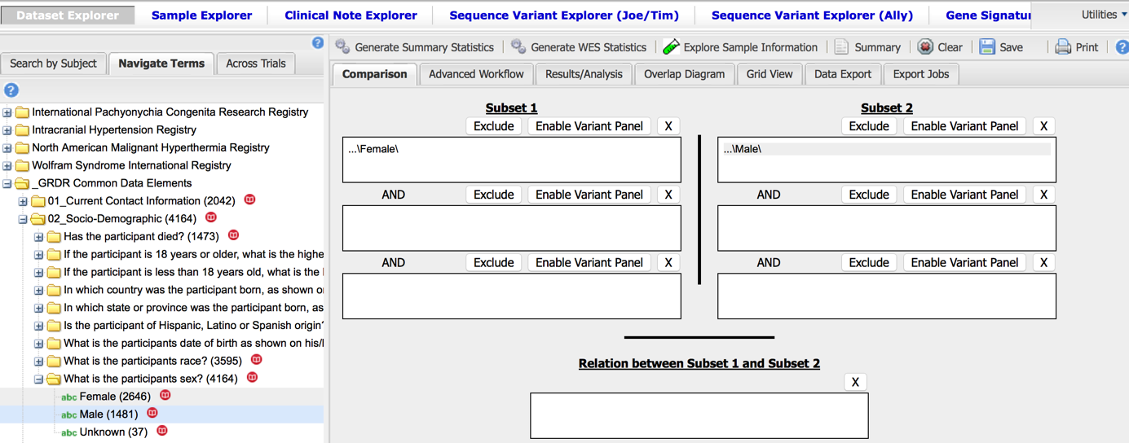

Fig 56: Subsets selection

Click on generate summary statistics

Then “drag” and “drop” the variable *What is the participant’s rare disease diagnosis?*

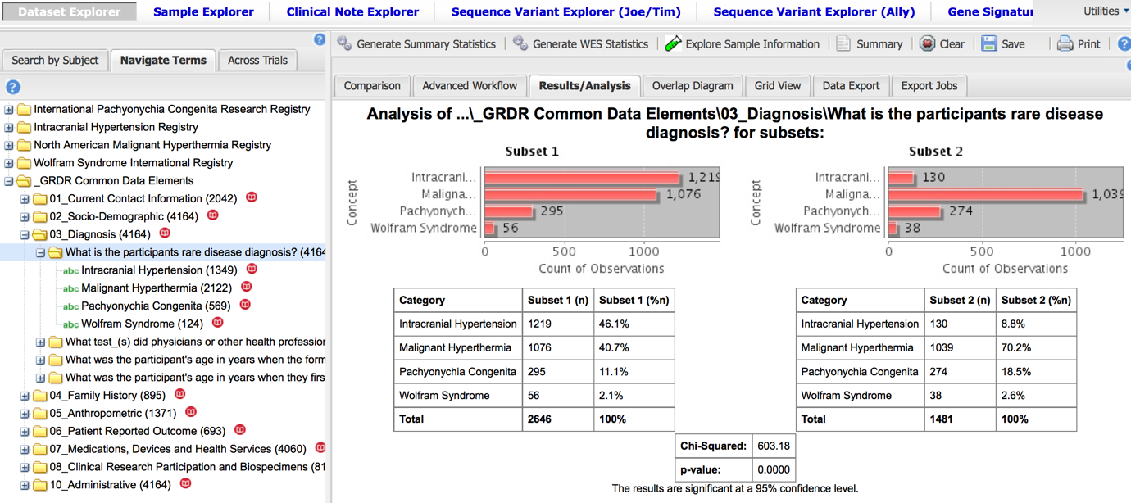

Fig 57: Result of Chi-squared test: p<0,0001: looking at the values, female gender is associated with rare disease diagnosis.

# **VIII. Annexes**

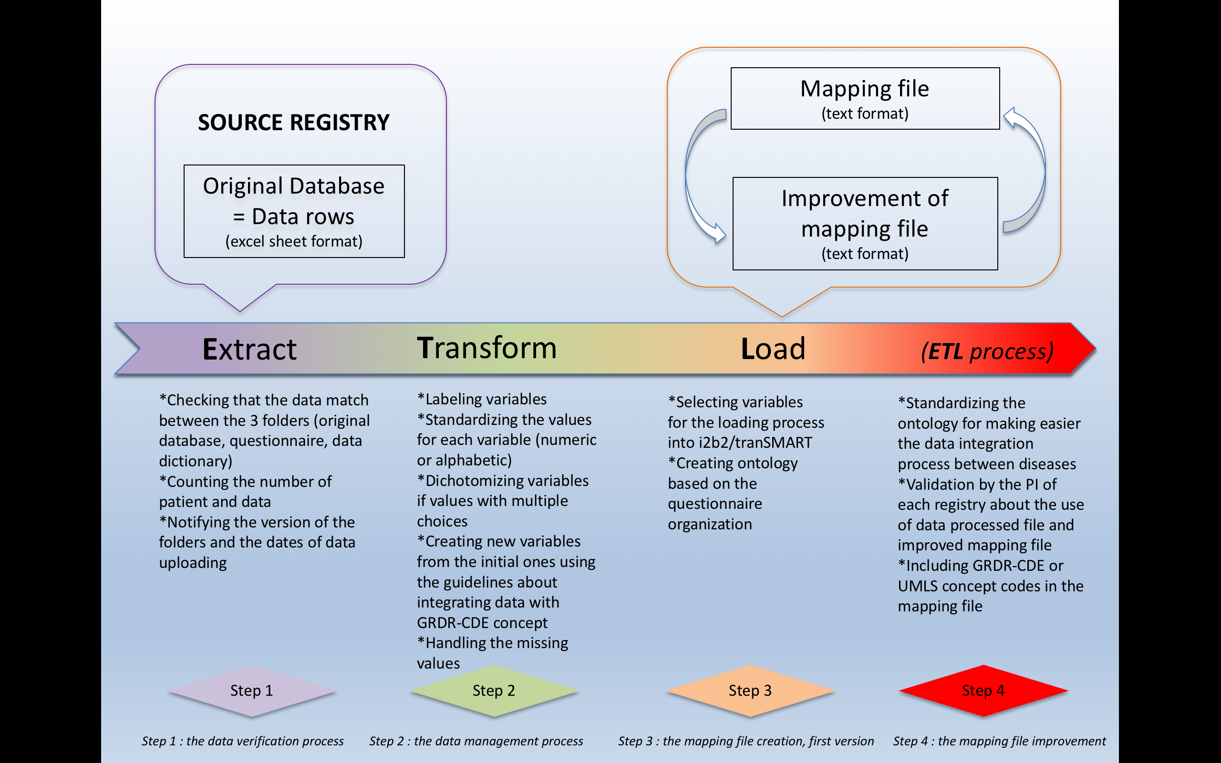

Fig 58 : ***ETL*** *process*: data from source registry to i2b2/tranSMART

# **IX. Bibliography**

1. Durcan FJ, Corbett JJ, Wall M. The incidence of pseudotumor cerebri. Population studies in Iowa and Louisiana. Arch Neurol. 1988 Aug;45(8):875–7.

2. Morgan WH, Balaratnasingam C, Lind CRP, Colley S, Kang MH, House PH, et al. Cerebrospinal fluid pressure and the eye. Br J Ophthalmol. 2016 Jan;100(1):71–7.

3. Spaunhurst KM, Hogendorf AM, Smith FJD, Lingala B, Schwartz ME, Cywinska-Bernas A, et al. Pachyonychia congenita patients with mutations in KRT6A have more extensive disease compared with patients who have mutations in KRT16. Br J Dermatol. 2012 Apr;166(4):875–8.

4. Gomez H, Kellum JA. Understanding Acid Base Disorders. Crit Care Clin. 2015 Oct;31(4):849–60.

5. Marshall BA, Permutt MA, Paciorkowski AR, Hoekel J, Karzon R, Wasson J, et al. Phenotypic characteristics of early Wolfram syndrome. Orphanet J Rare Dis. 2013;8:64.